Table of Contents

B) ZERO GEN. POWER: Generator Bus Voltage 2

B) ZERO GEN. POWER: Active Power 3

B) ZERO GEN. POWER: Reactive Power 4

B) ZERO GEN. POWER: Generator Stator Current 5

B) ZERO GEN. POWER: Excitation Voltage 6

B) ZERO GEN. POWER: Excitation Current 7

B) ZERO GEN. POWER: Generator Speed 8

B) ZERO GEN. POWER: Gen. Frequency Deviation 9

B) ZERO GEN. POWER: Ext. Rotor Angle 10

B) ZERO GEN. POWER: Int. Rotor Angle 11

C) NOMINAL GEN. ACT. POWER: Generator Bus Voltage 12

C) NOMINAL GEN. ACT. POWER: Active Power 13

C) NOMINAL GEN. ACT. POWER: Reactive Power 14

C) NOMINAL GEN. ACT. POWER: Generator Stator Current 15

C) NOMINAL GEN. ACT. POWER: Excitation Voltage 17

C) NOMINAL GEN. ACT. POWER: Excitation Current 18

C) NOMINAL GEN. ACT. POWER: Generator Speed 19

C) NOMINAL GEN. ACT. POWER: Gen. Frequency Deviation 20

C) NOMINAL GEN. ACT. POWER: Ext. Rotor Angle 22

C) NOMINAL GEN. ACT. POWER: Int. Rotor Angle 23

# B) ZERO GEN. POWER: Generator Bus Voltage

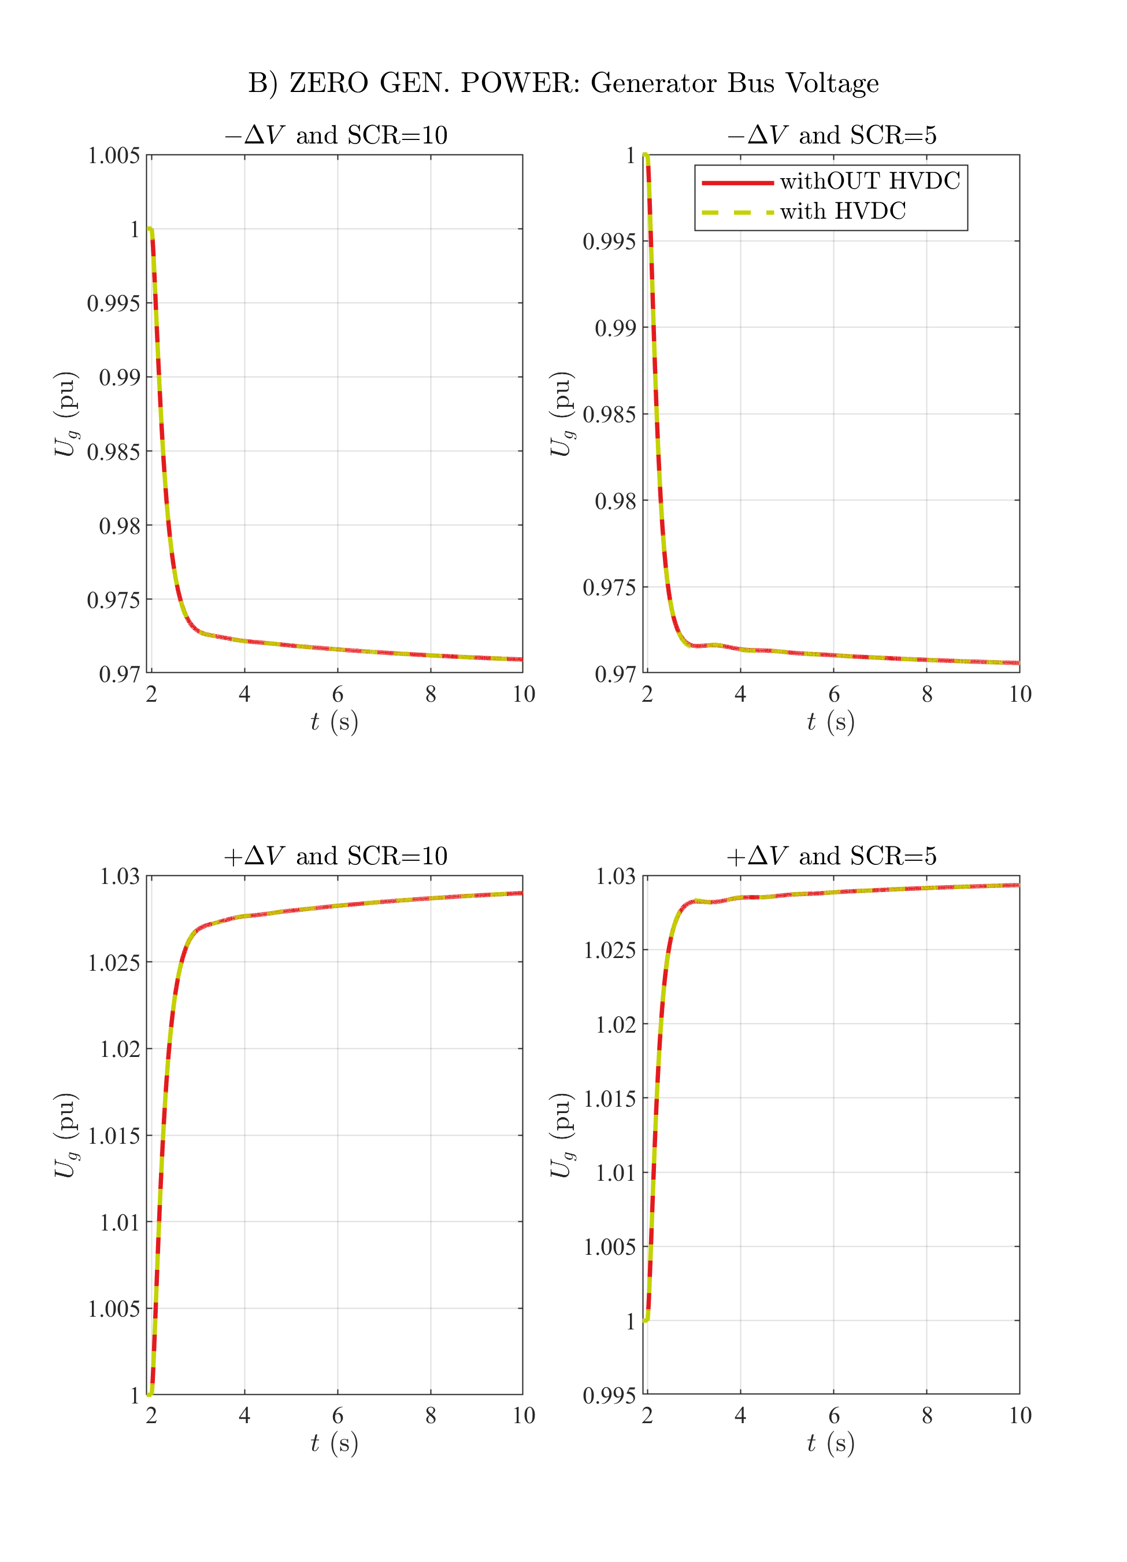

# B) ZERO GEN. POWER: Active Power

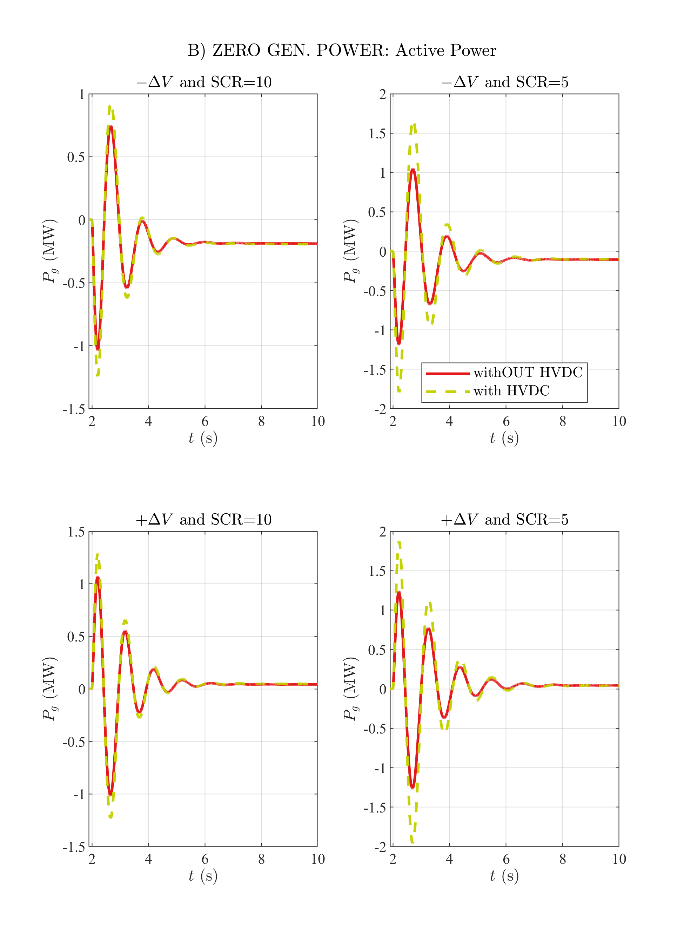

# B) ZERO GEN. POWER: Reactive Power

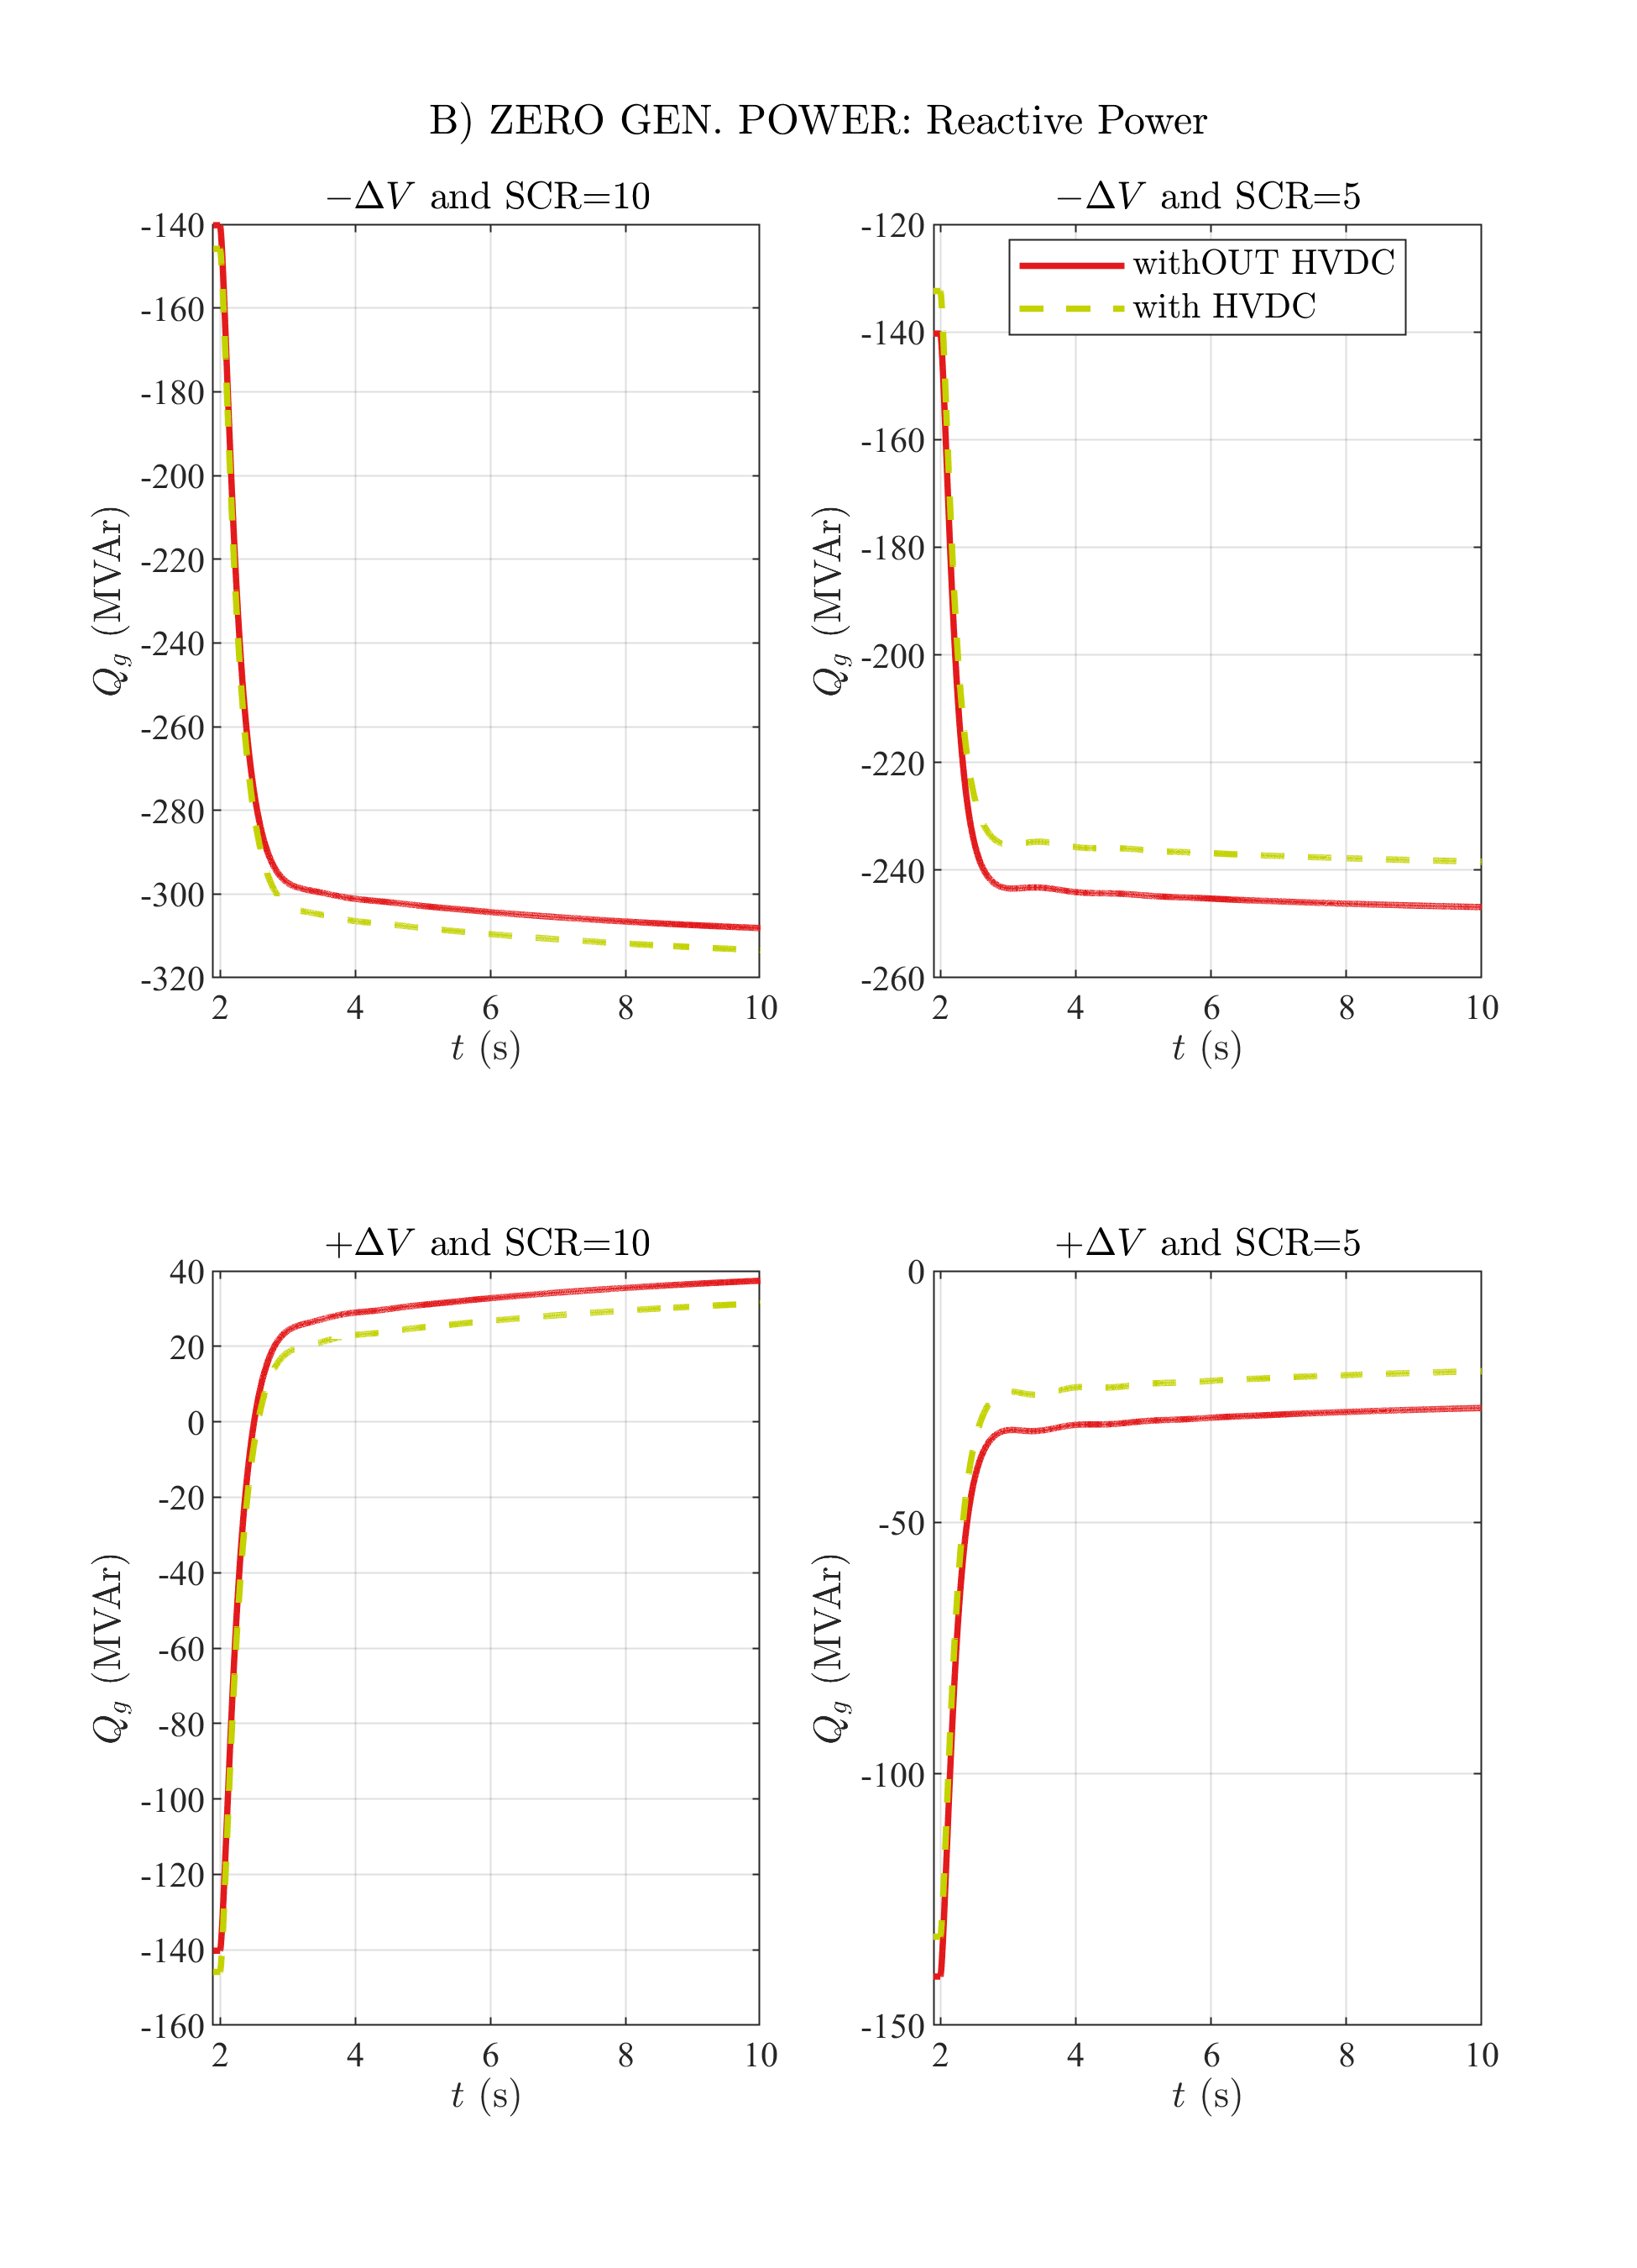

# B) ZERO GEN. POWER: Generator Stator Current

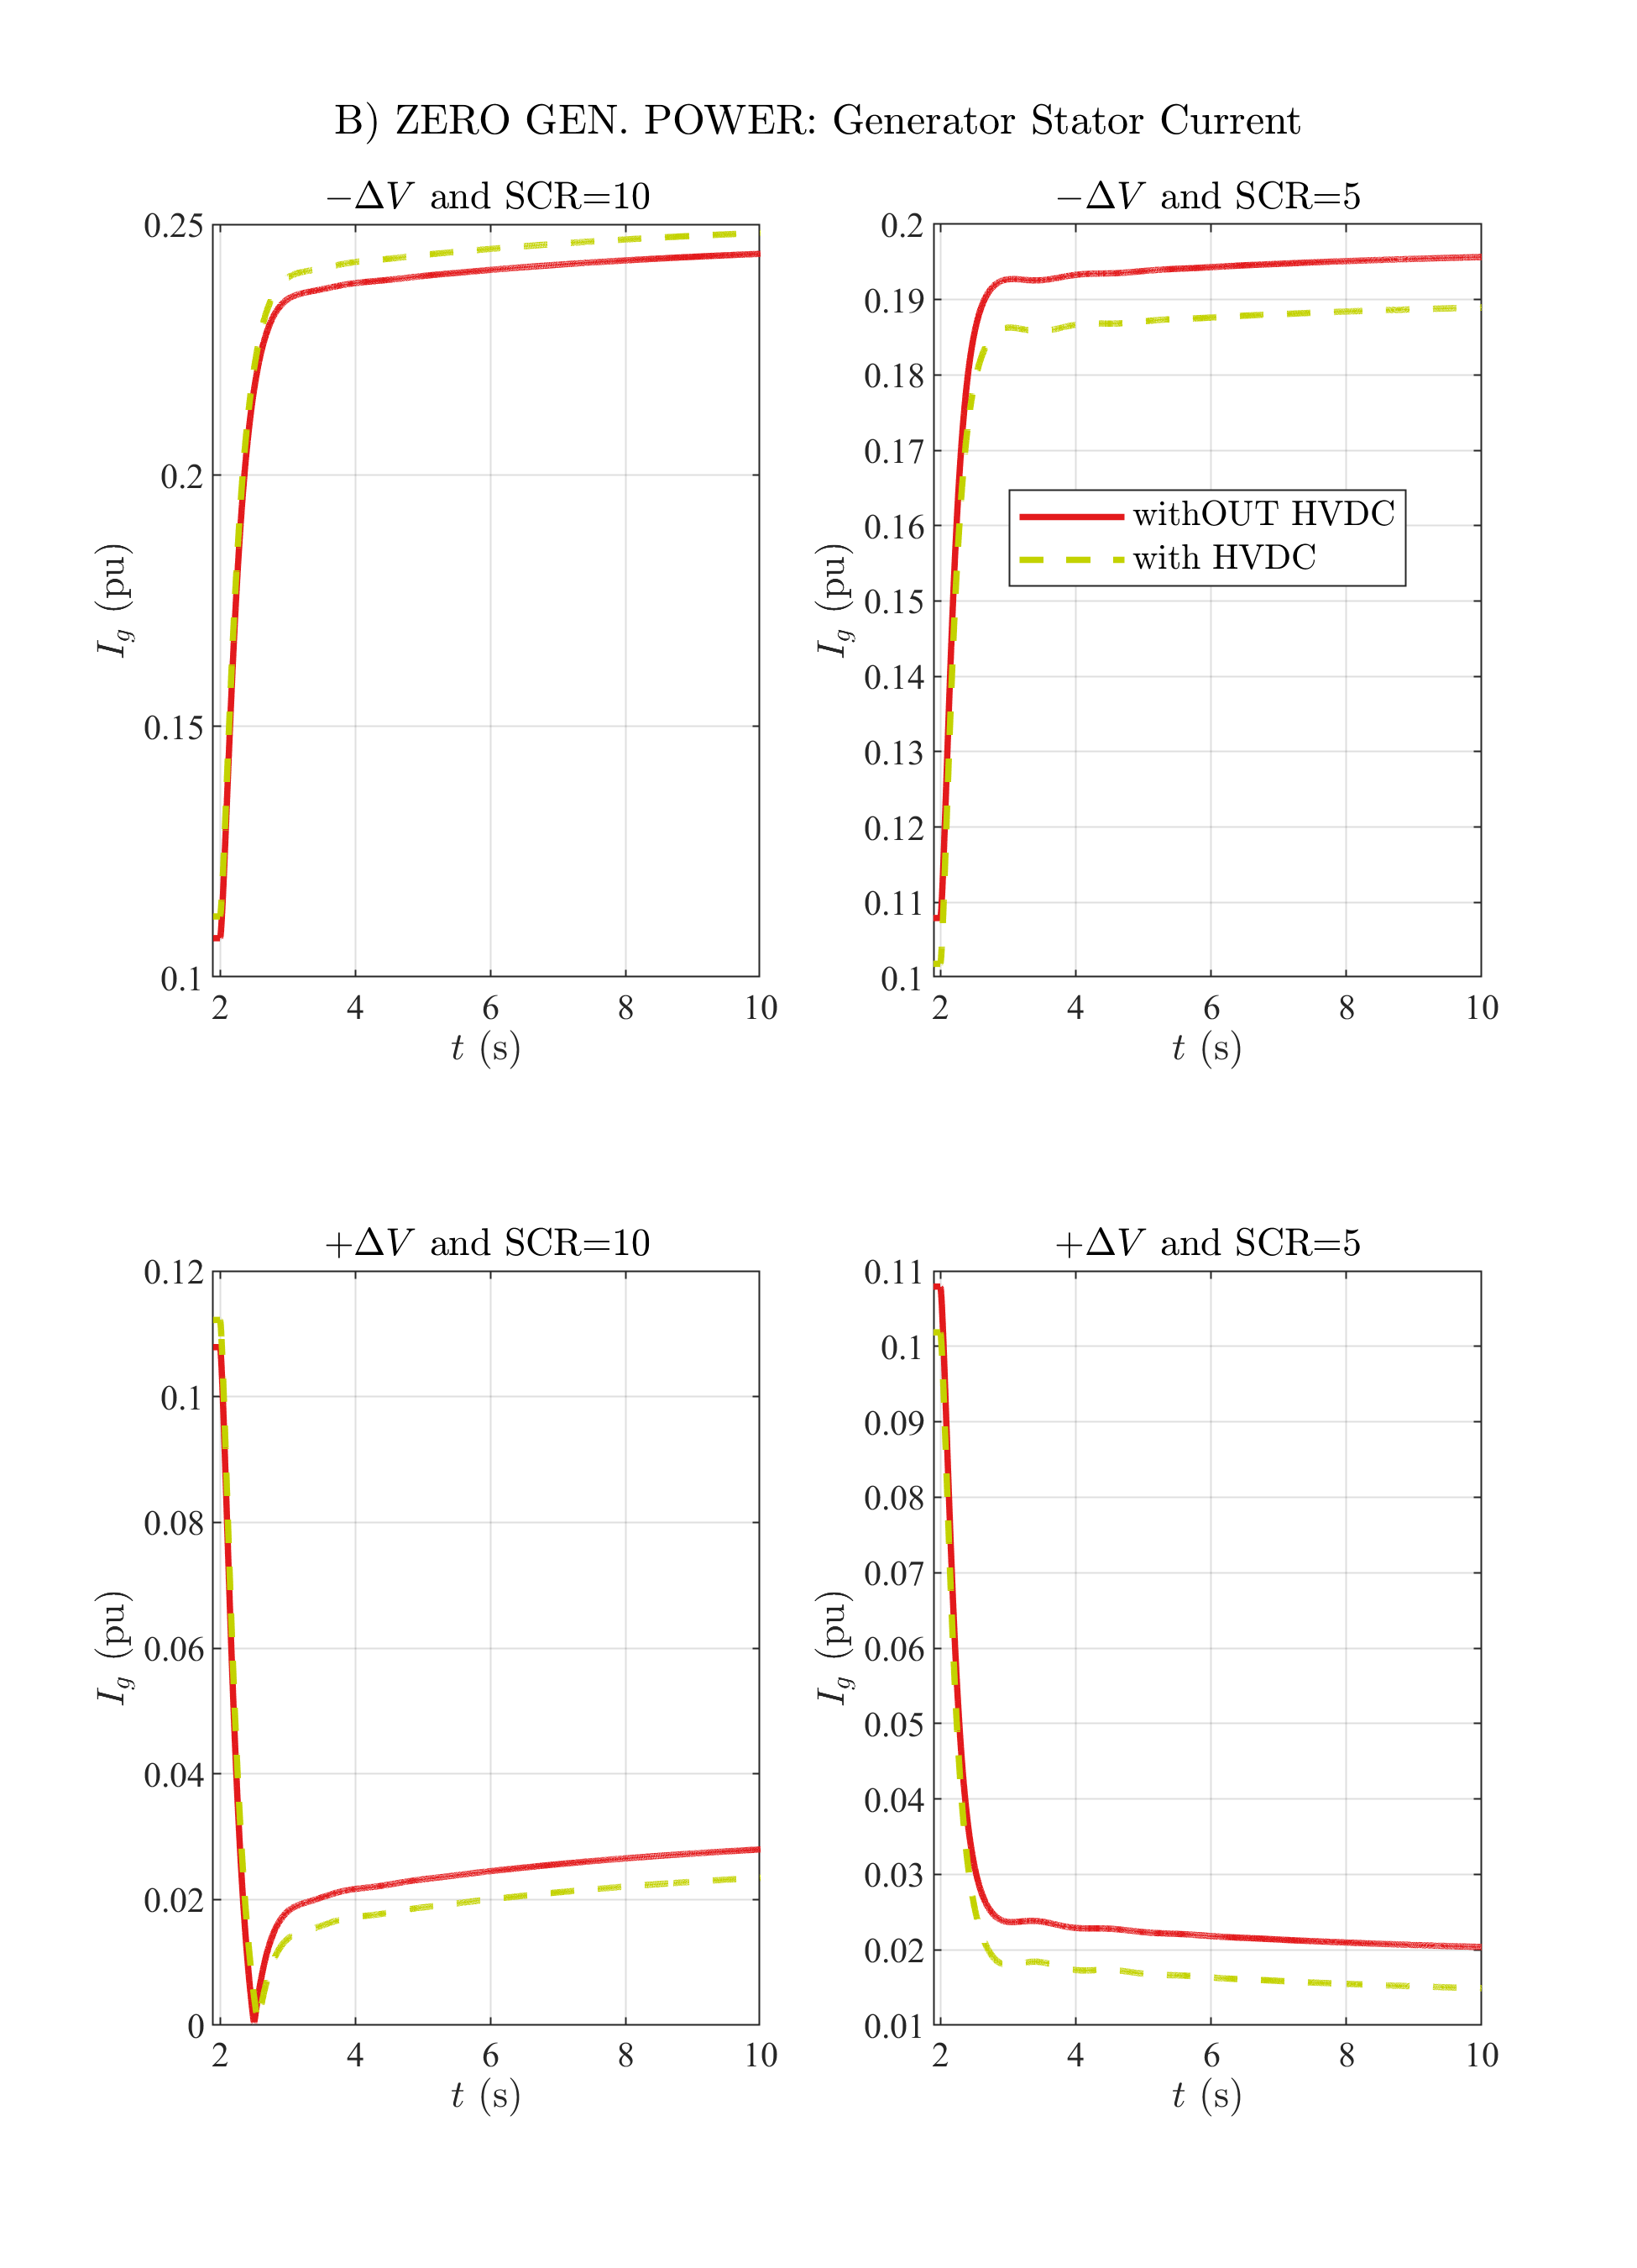

# B) ZERO GEN. POWER: Excitation Voltage

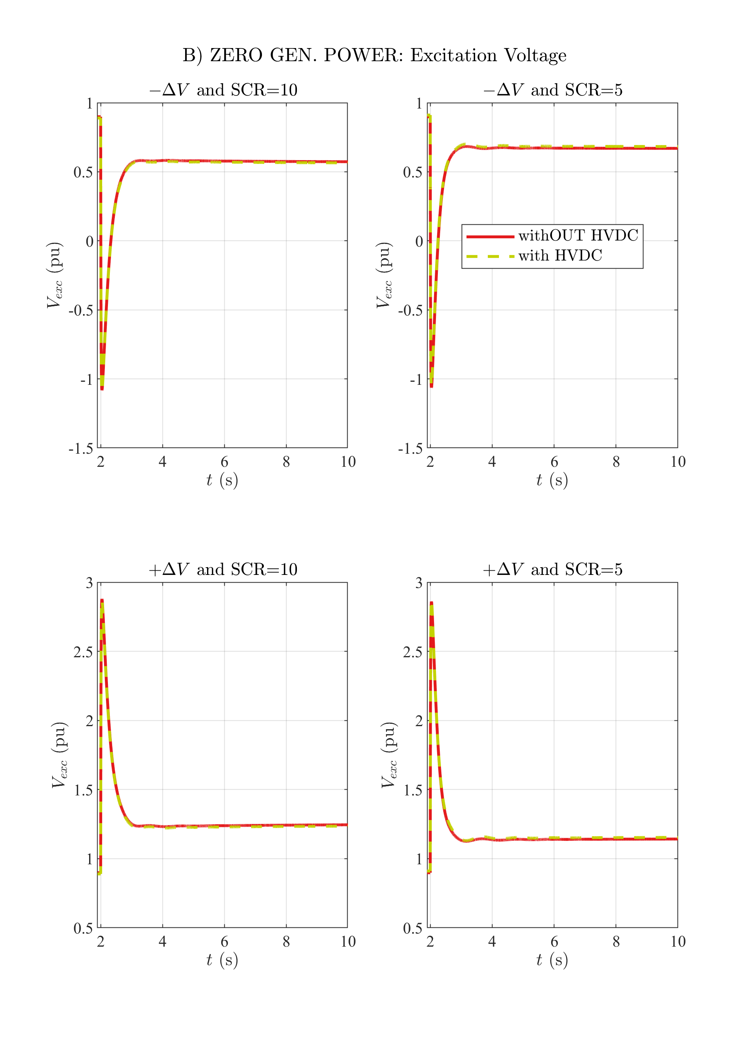

# B) ZERO GEN. POWER: Excitation Current

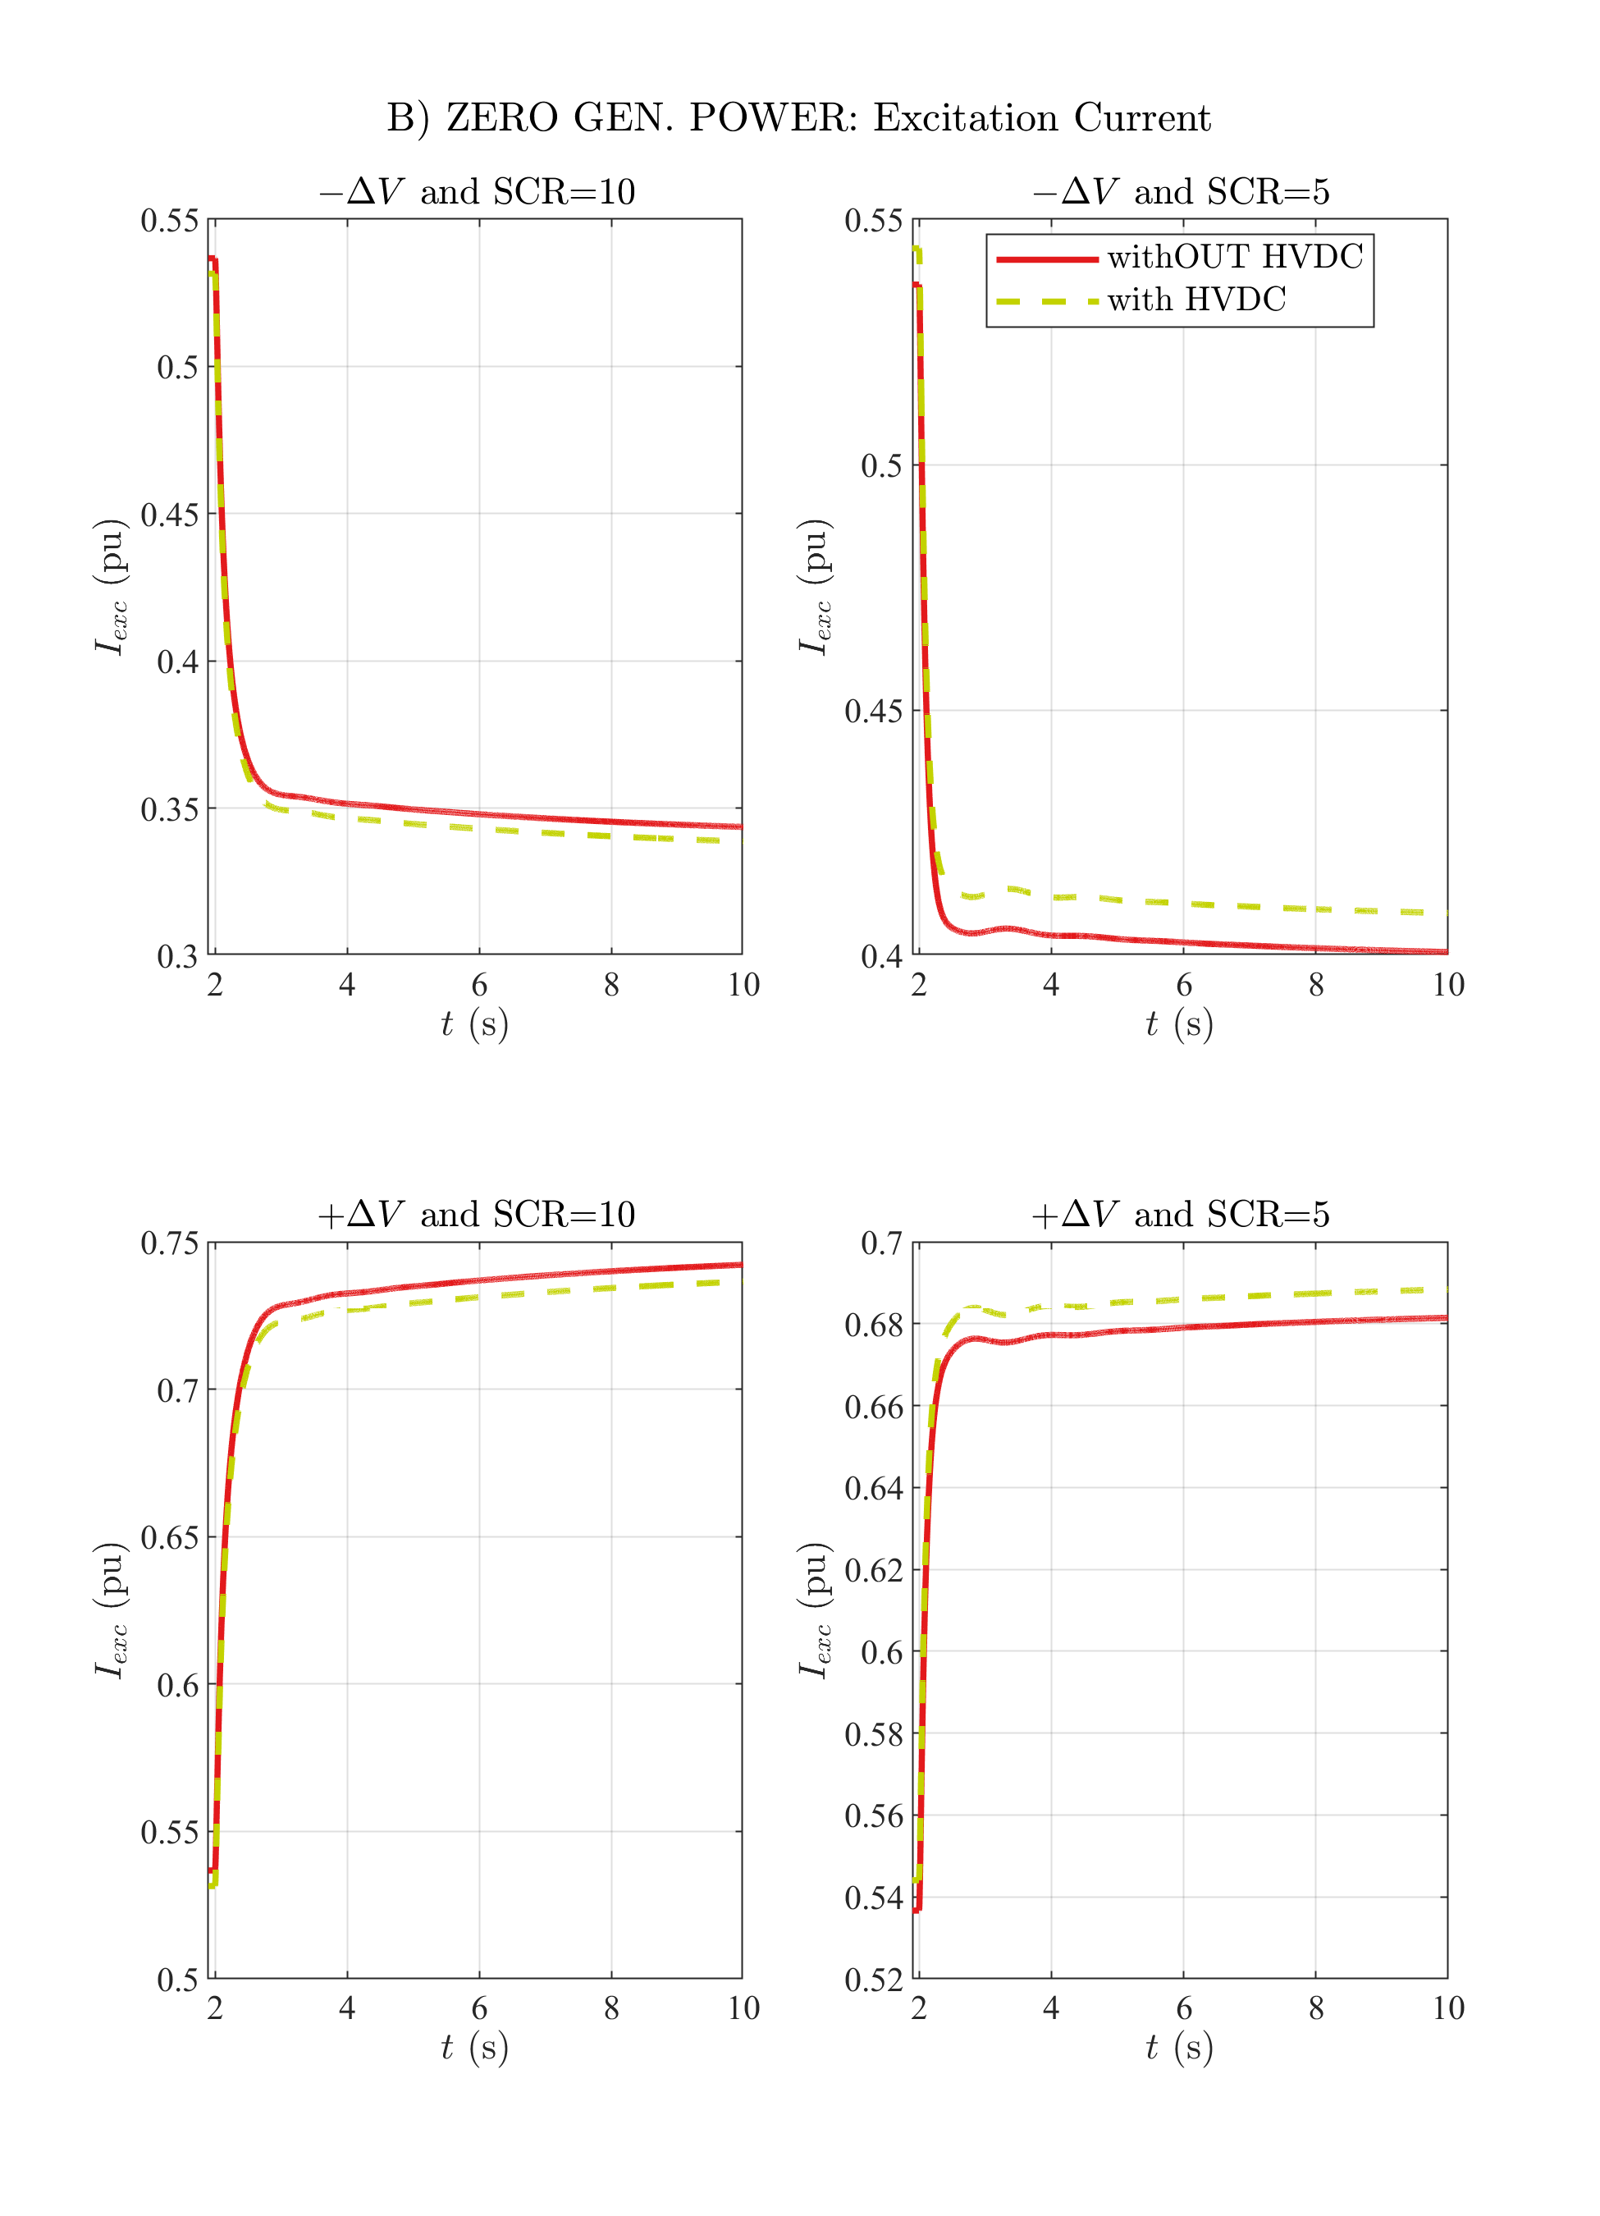

# B) ZERO GEN. POWER: Generator Speed

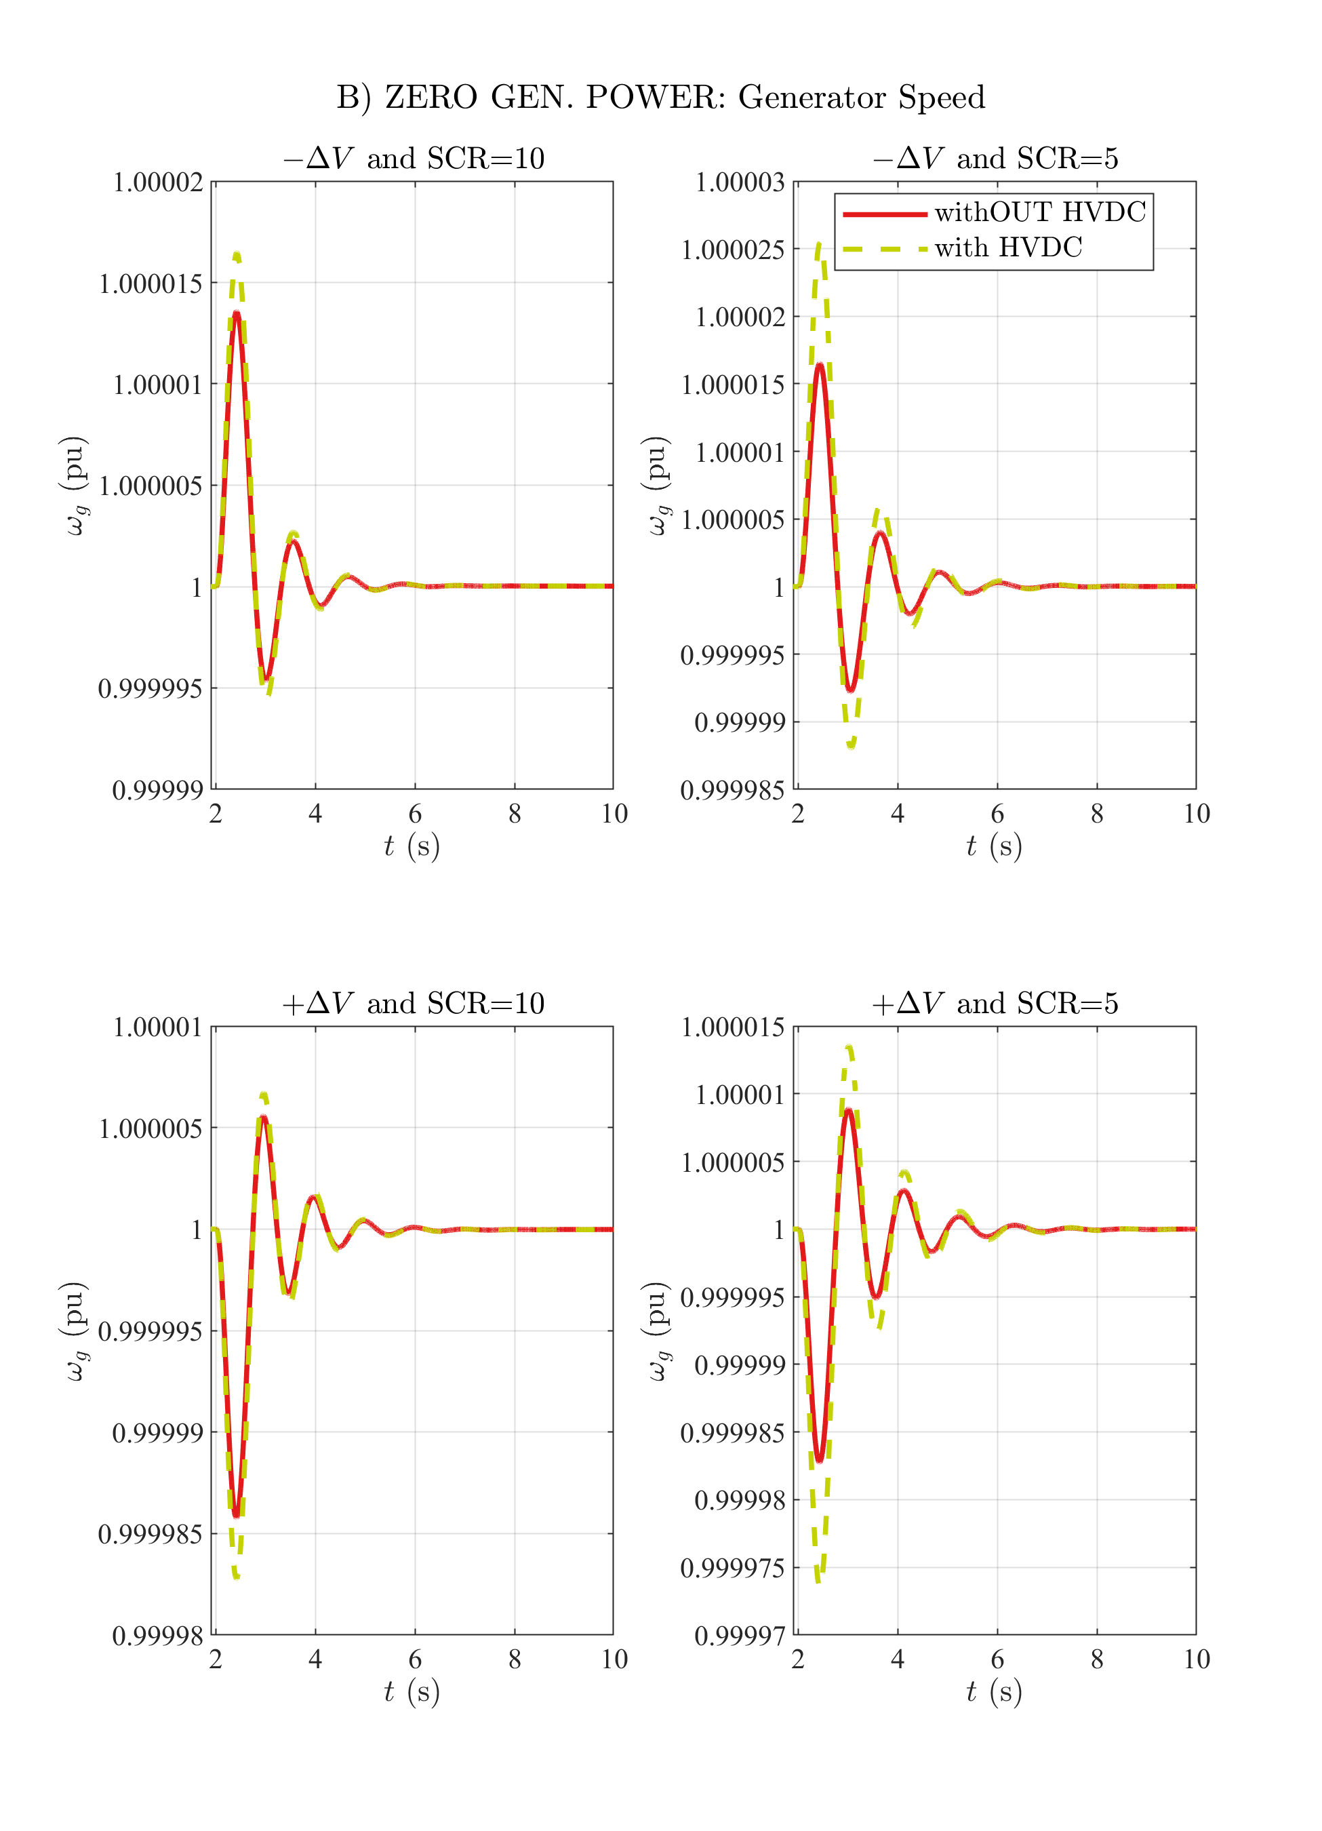

# B) ZERO GEN. POWER: Gen. Frequency Deviation

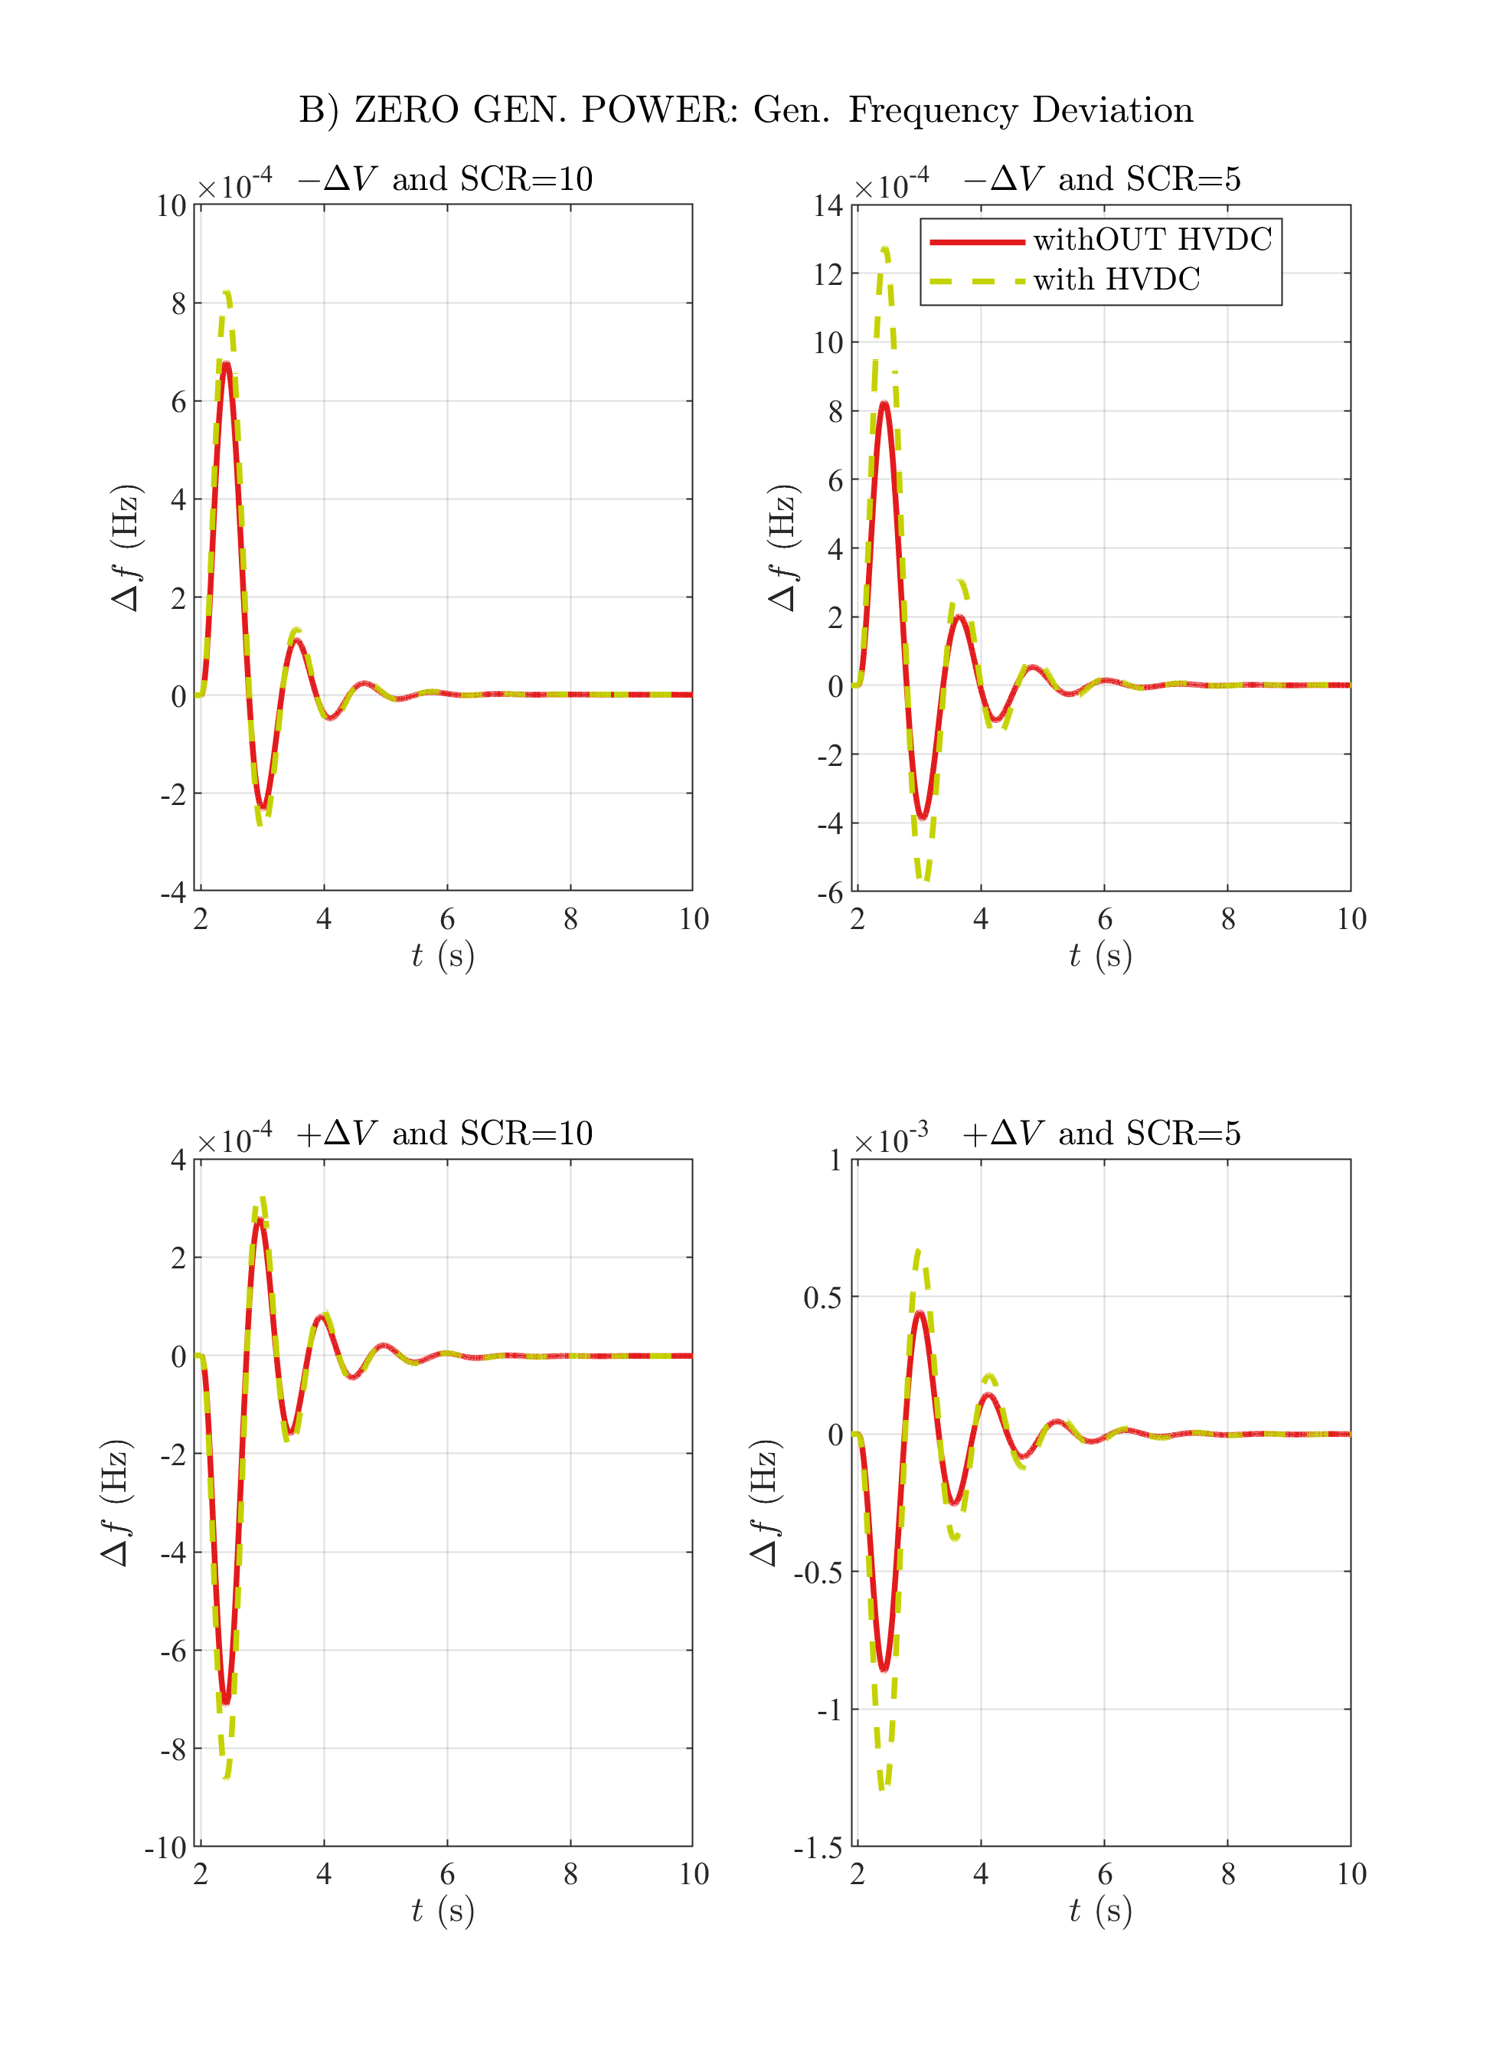

# B) ZERO GEN. POWER: Ext. Rotor Angle

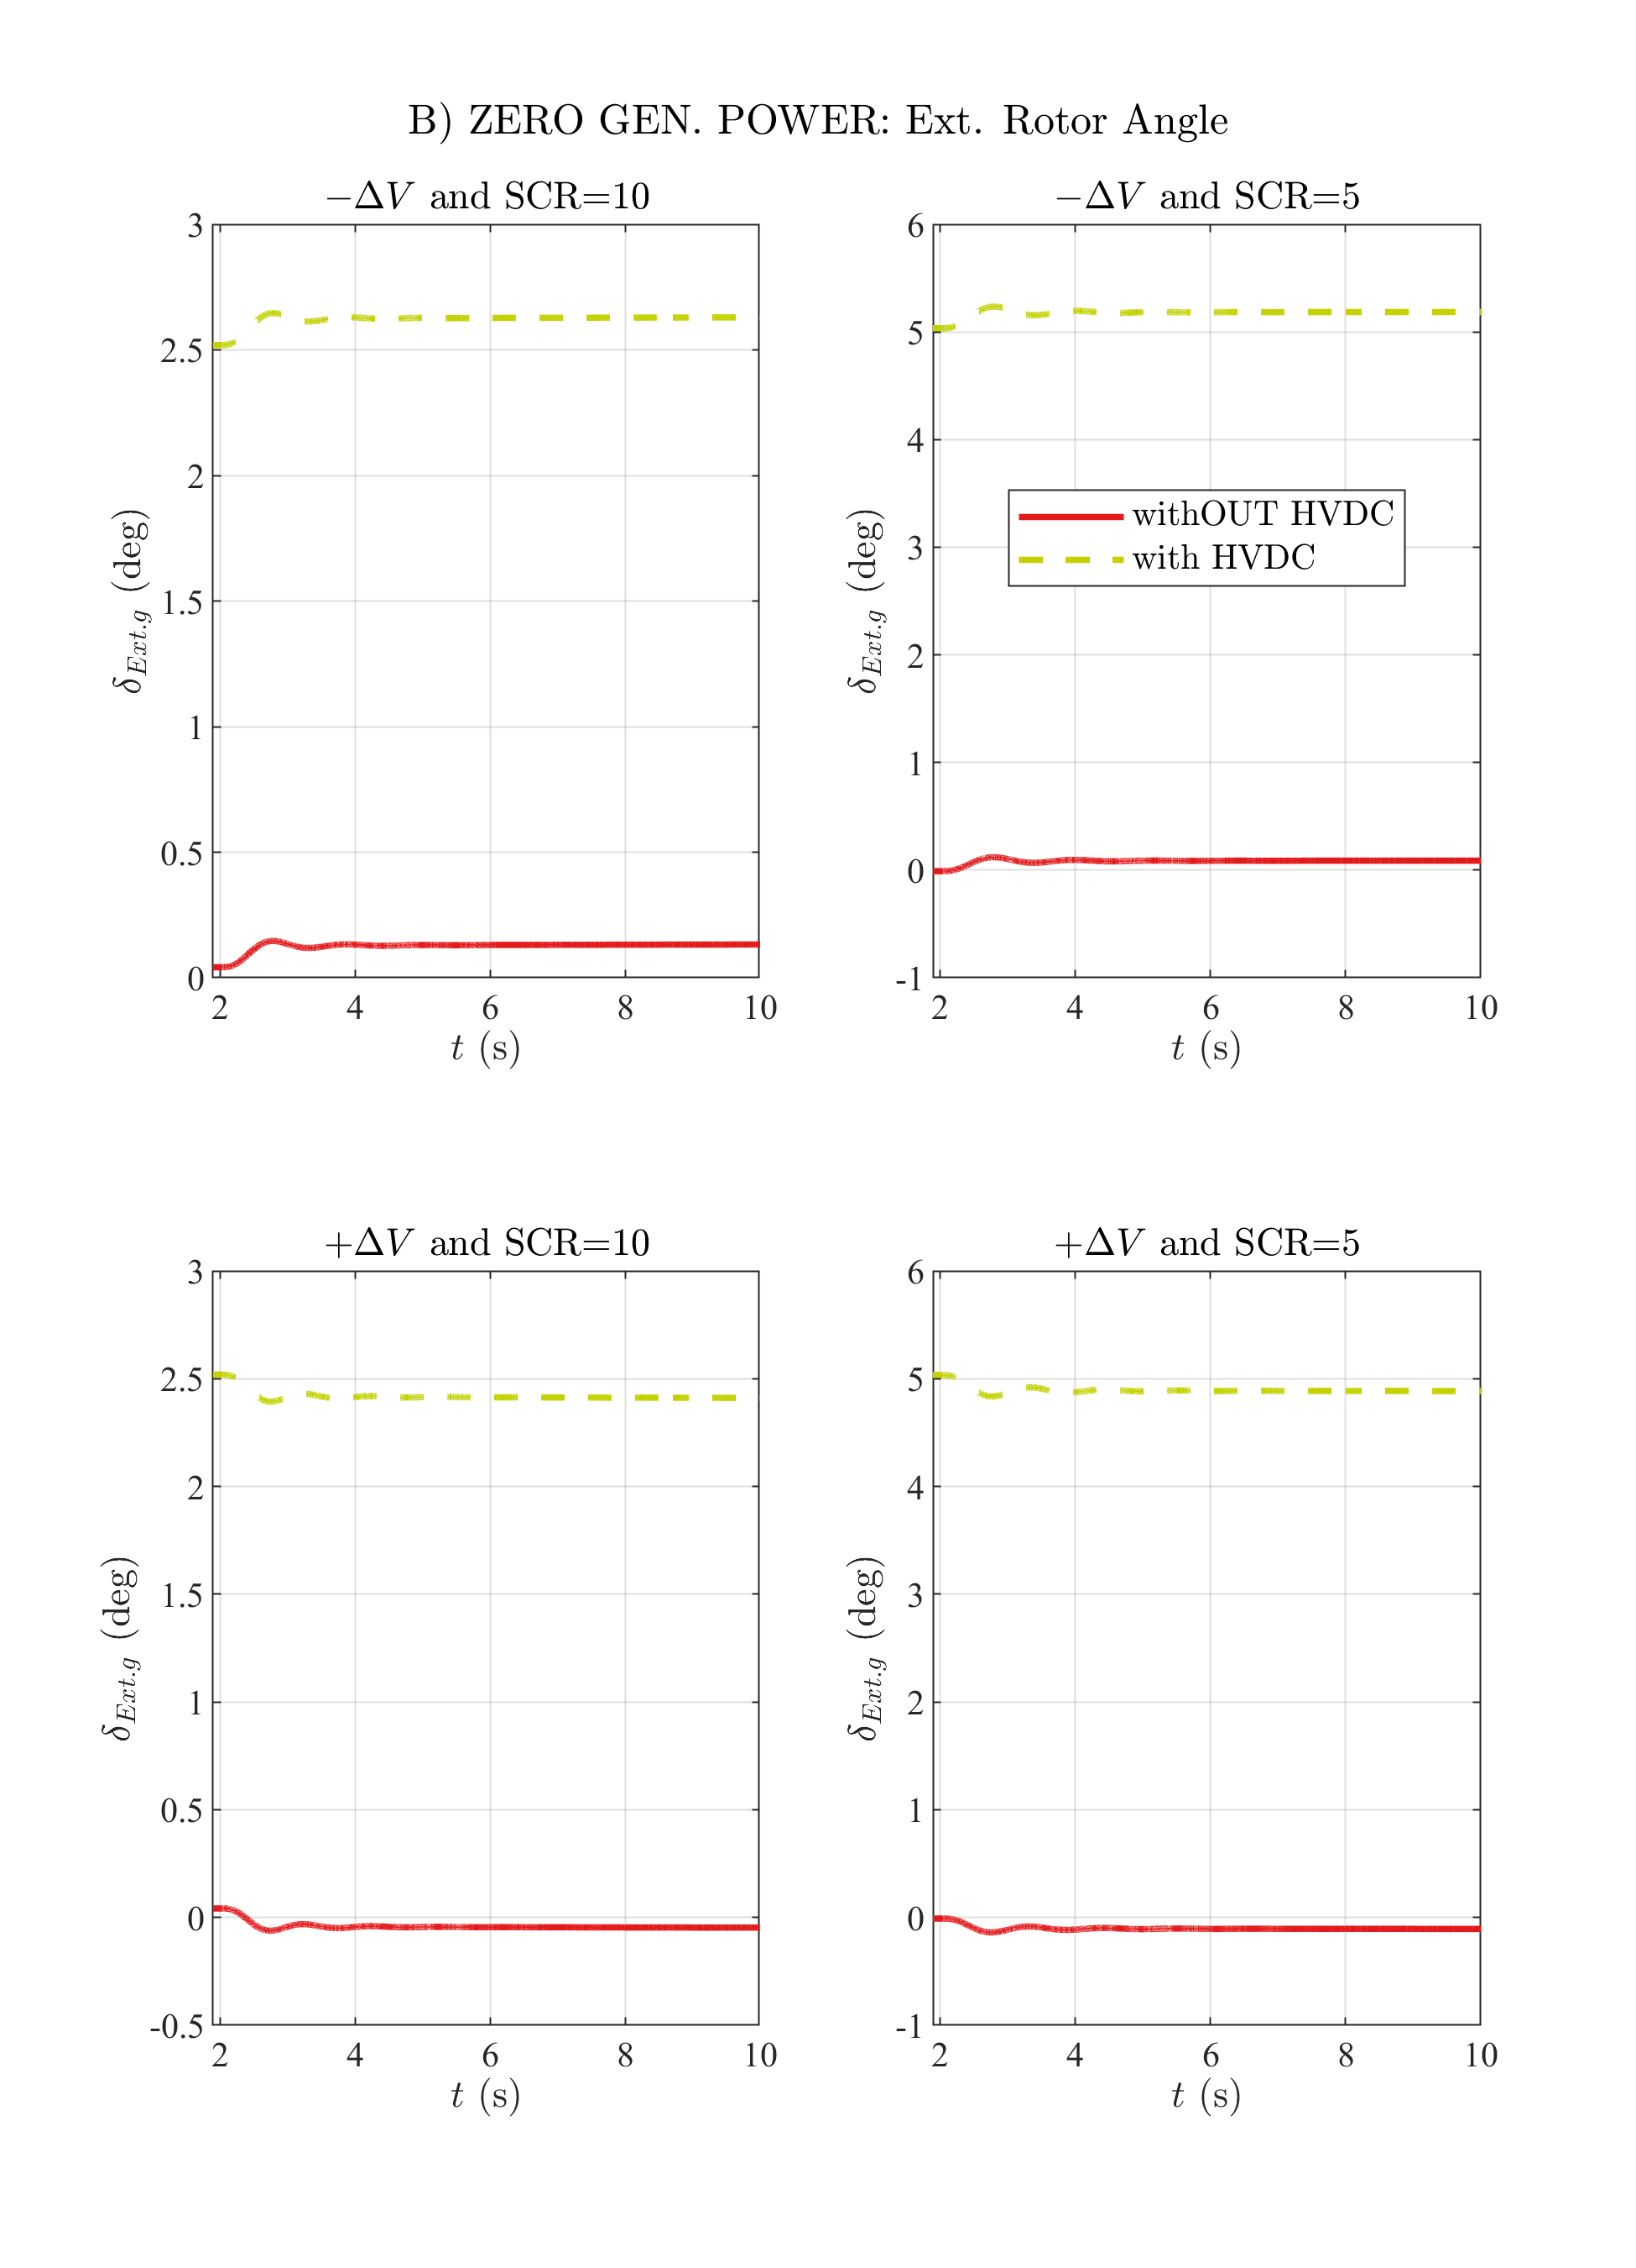

# B) ZERO GEN. POWER: Int. Rotor Angle

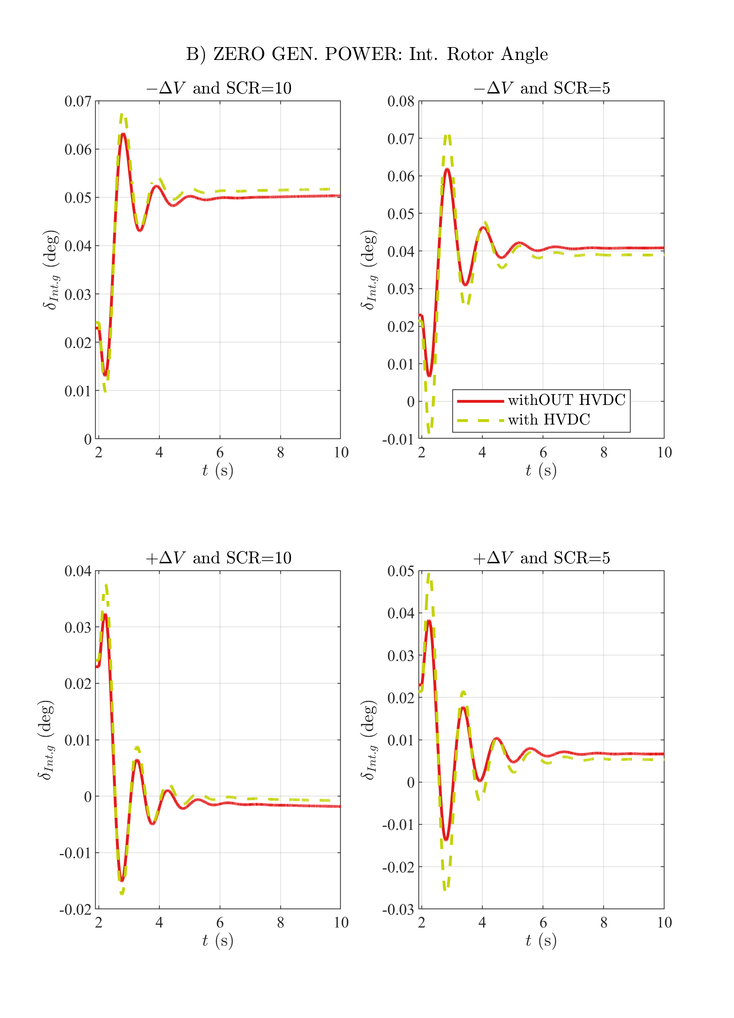

# C) NOMINAL GEN. ACT. POWER: Generator Bus Voltage

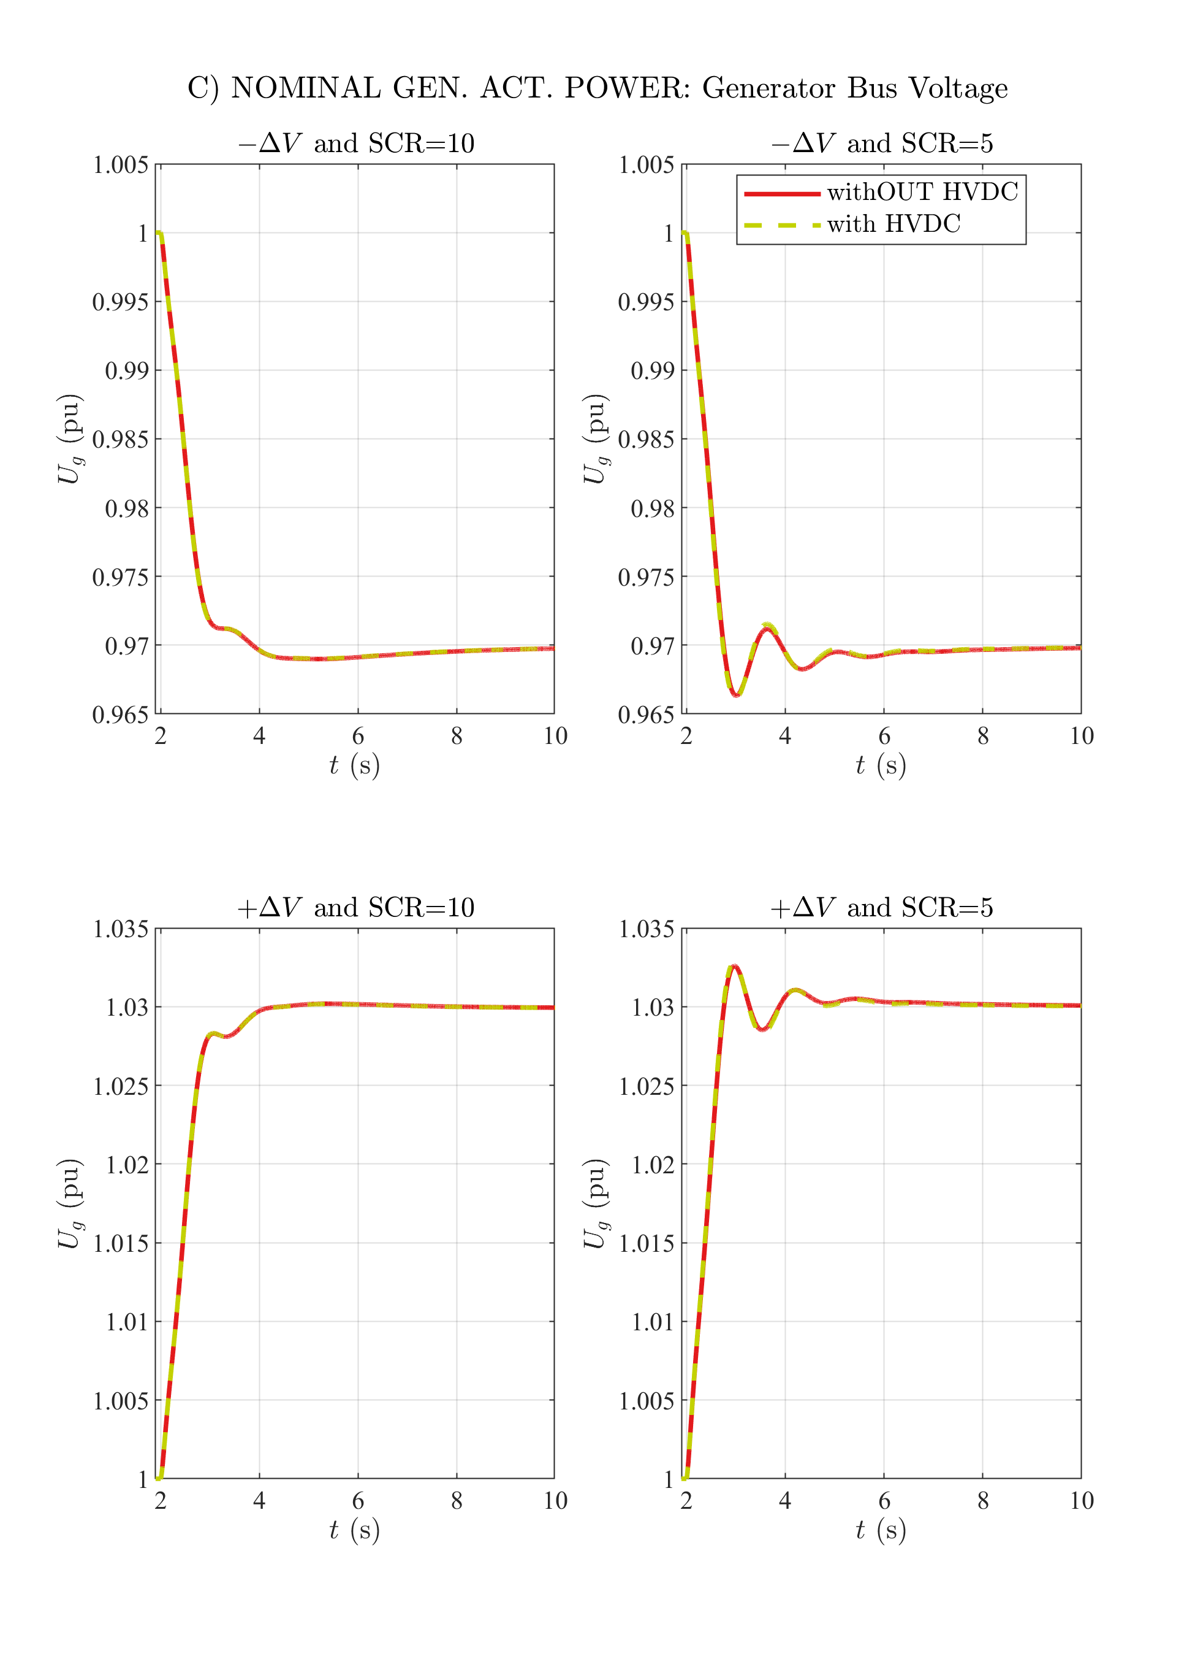

# C) NOMINAL GEN. ACT. POWER: Active Power

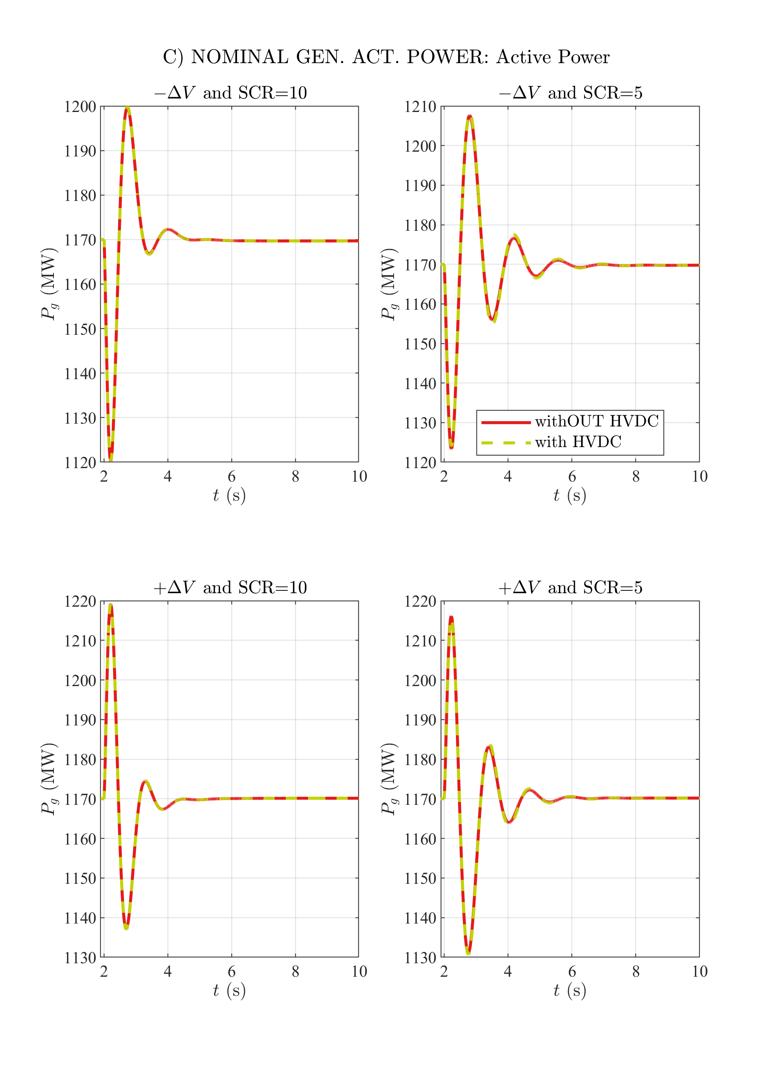

# C) NOMINAL GEN. ACT. POWER: Reactive Power

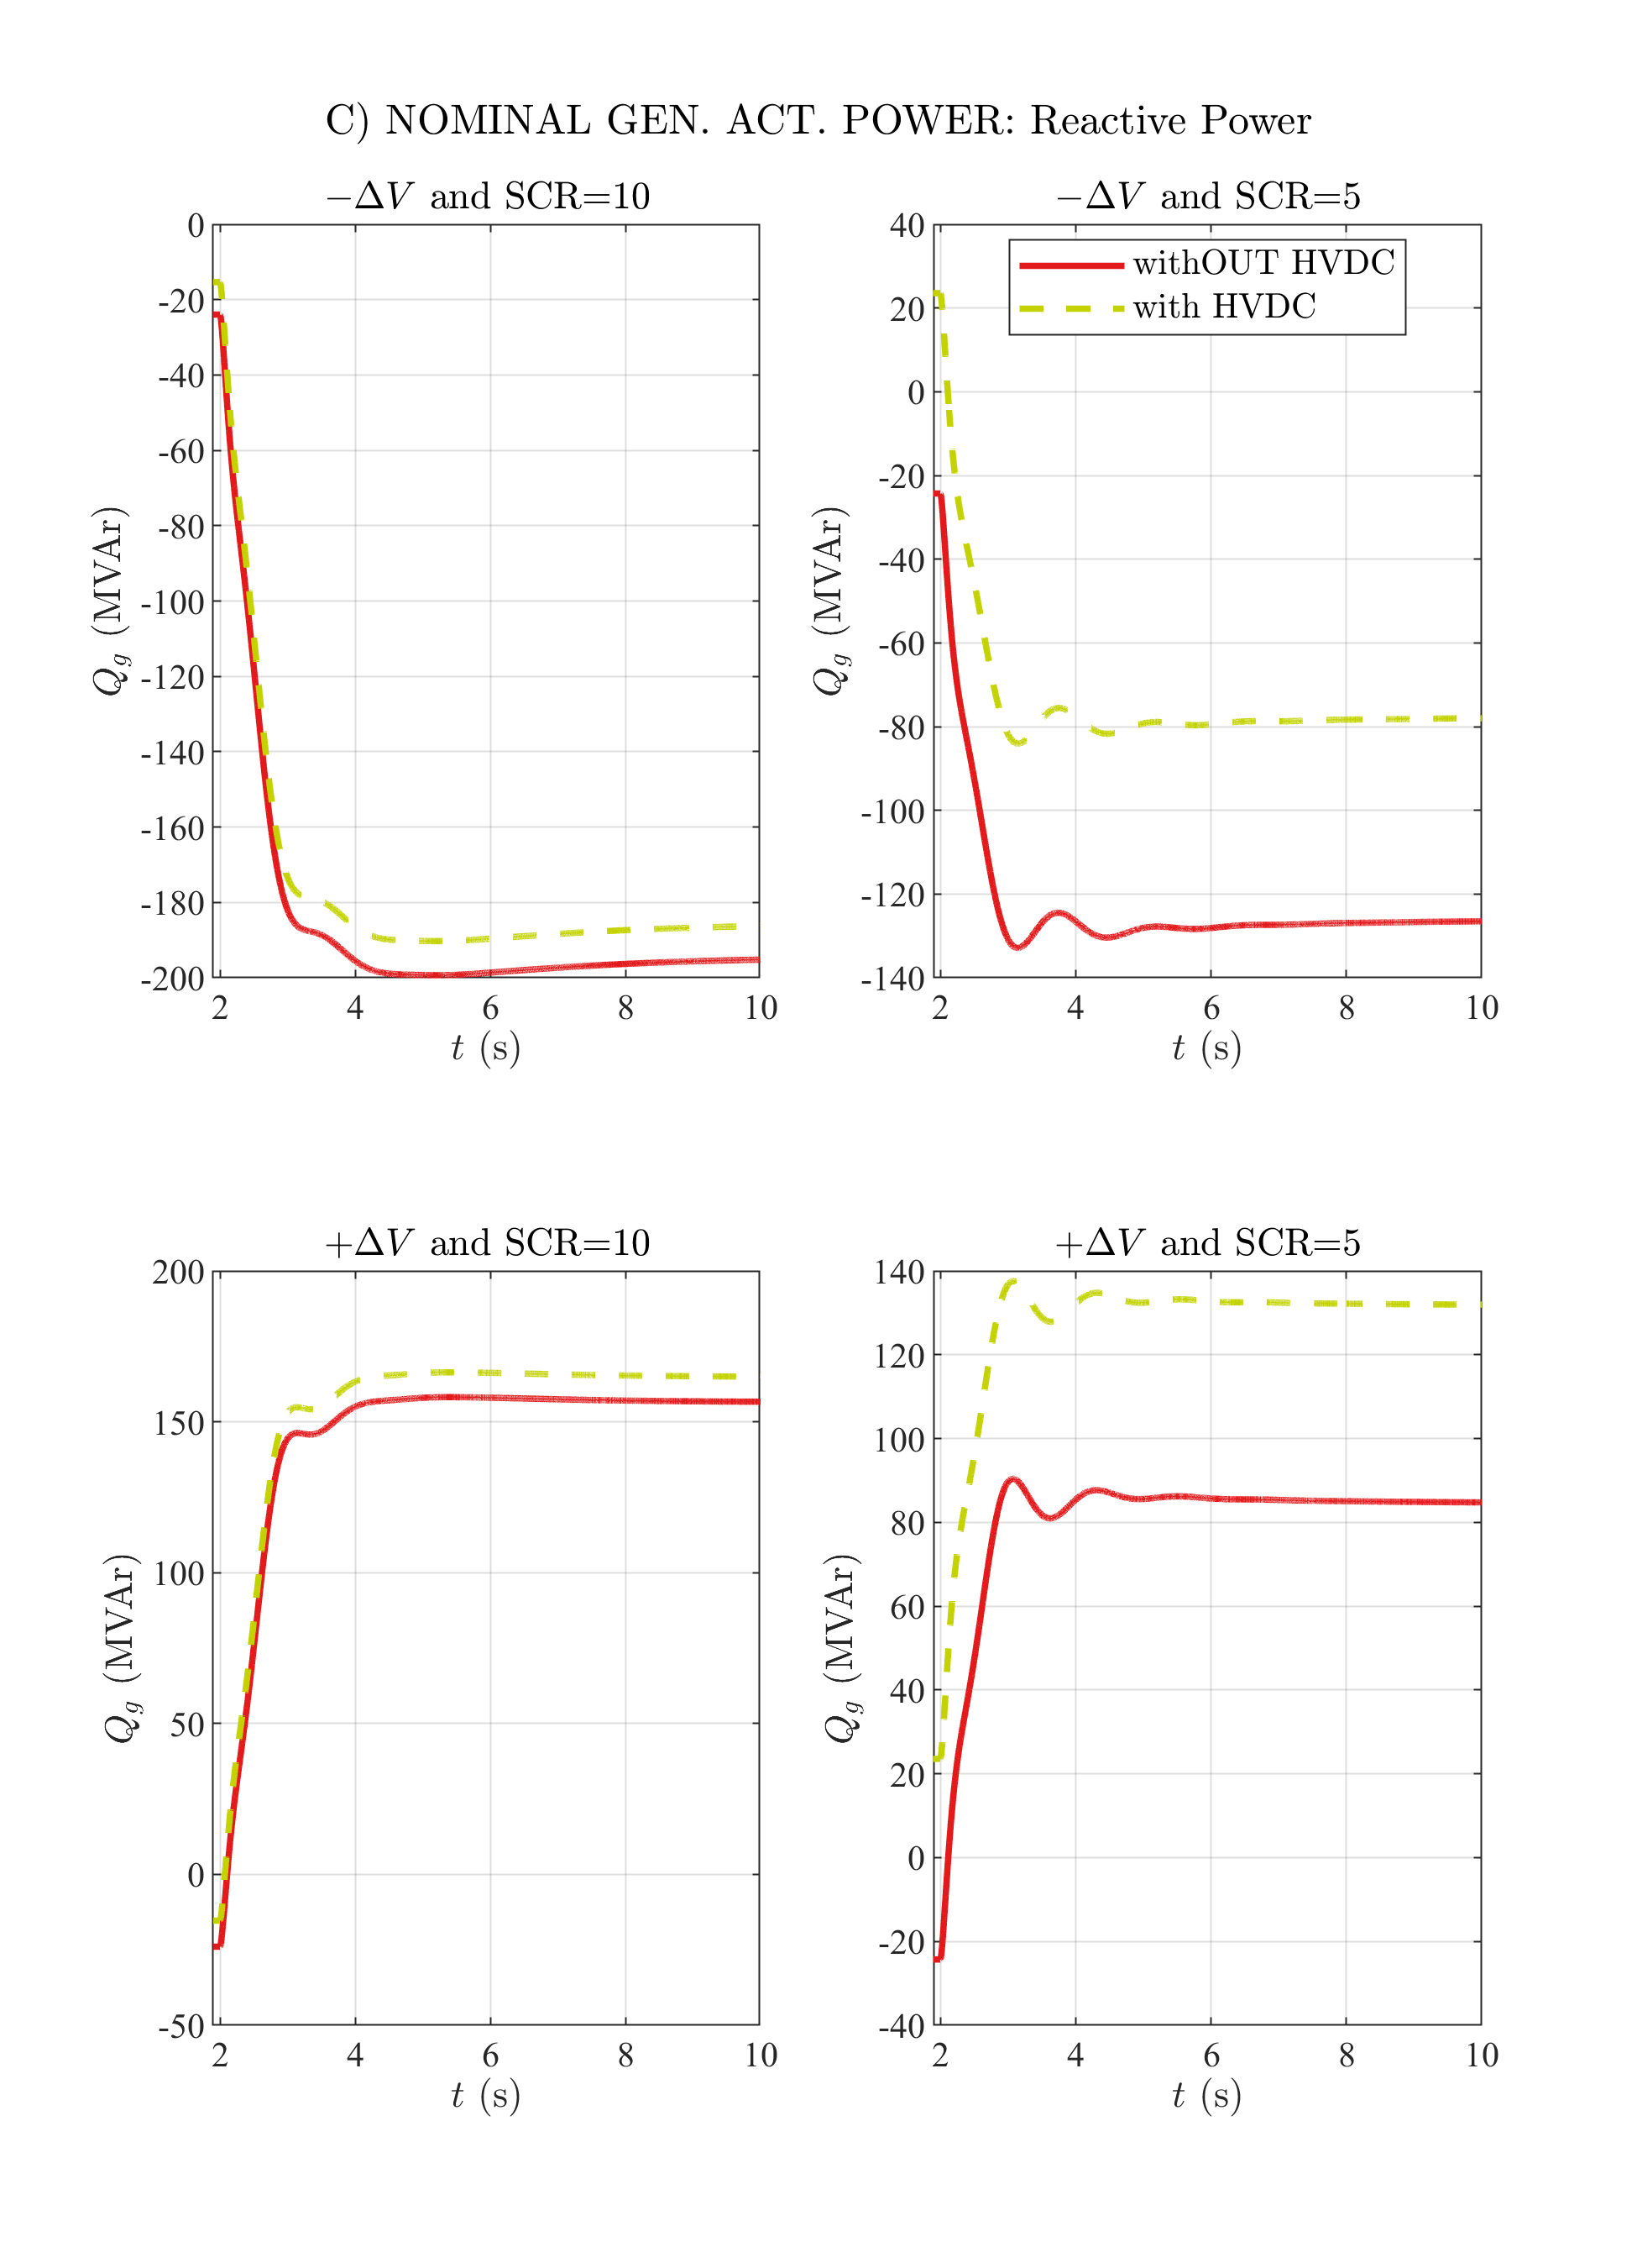

# C) NOMINAL GEN. ACT. POWER: Generator Stator Current

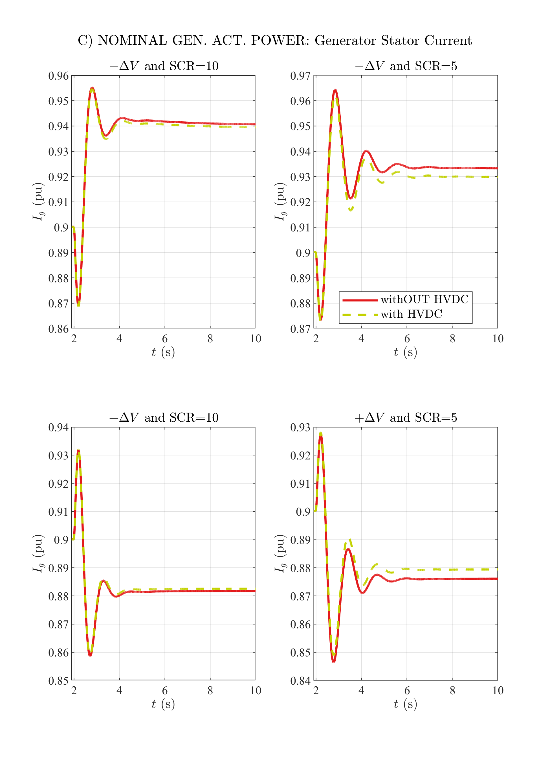

# C) NOMINAL GEN. ACT. POWER: Excitation Voltage

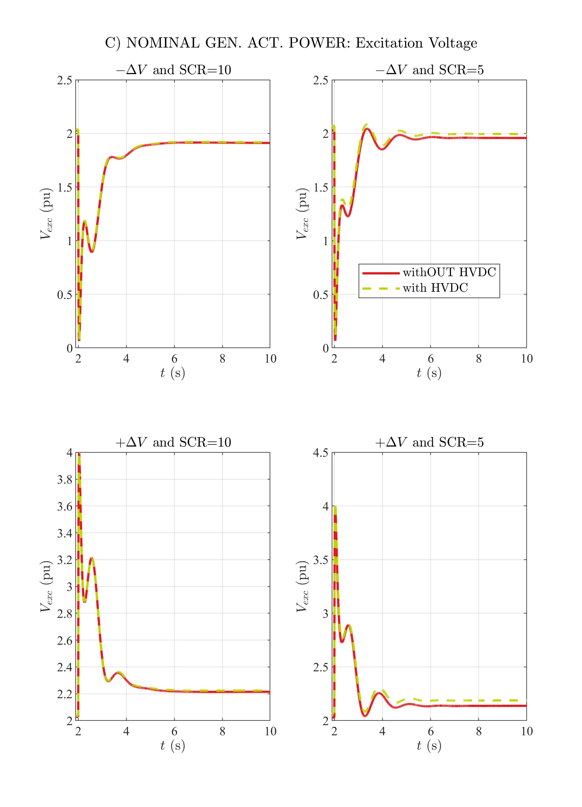

# C) NOMINAL GEN. ACT. POWER: Excitation Current

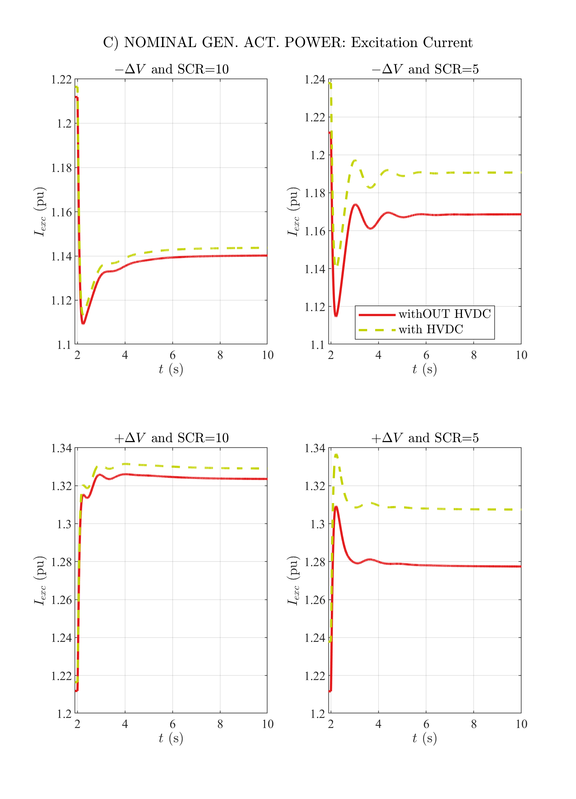

# C) NOMINAL GEN. ACT. POWER: Generator Speed

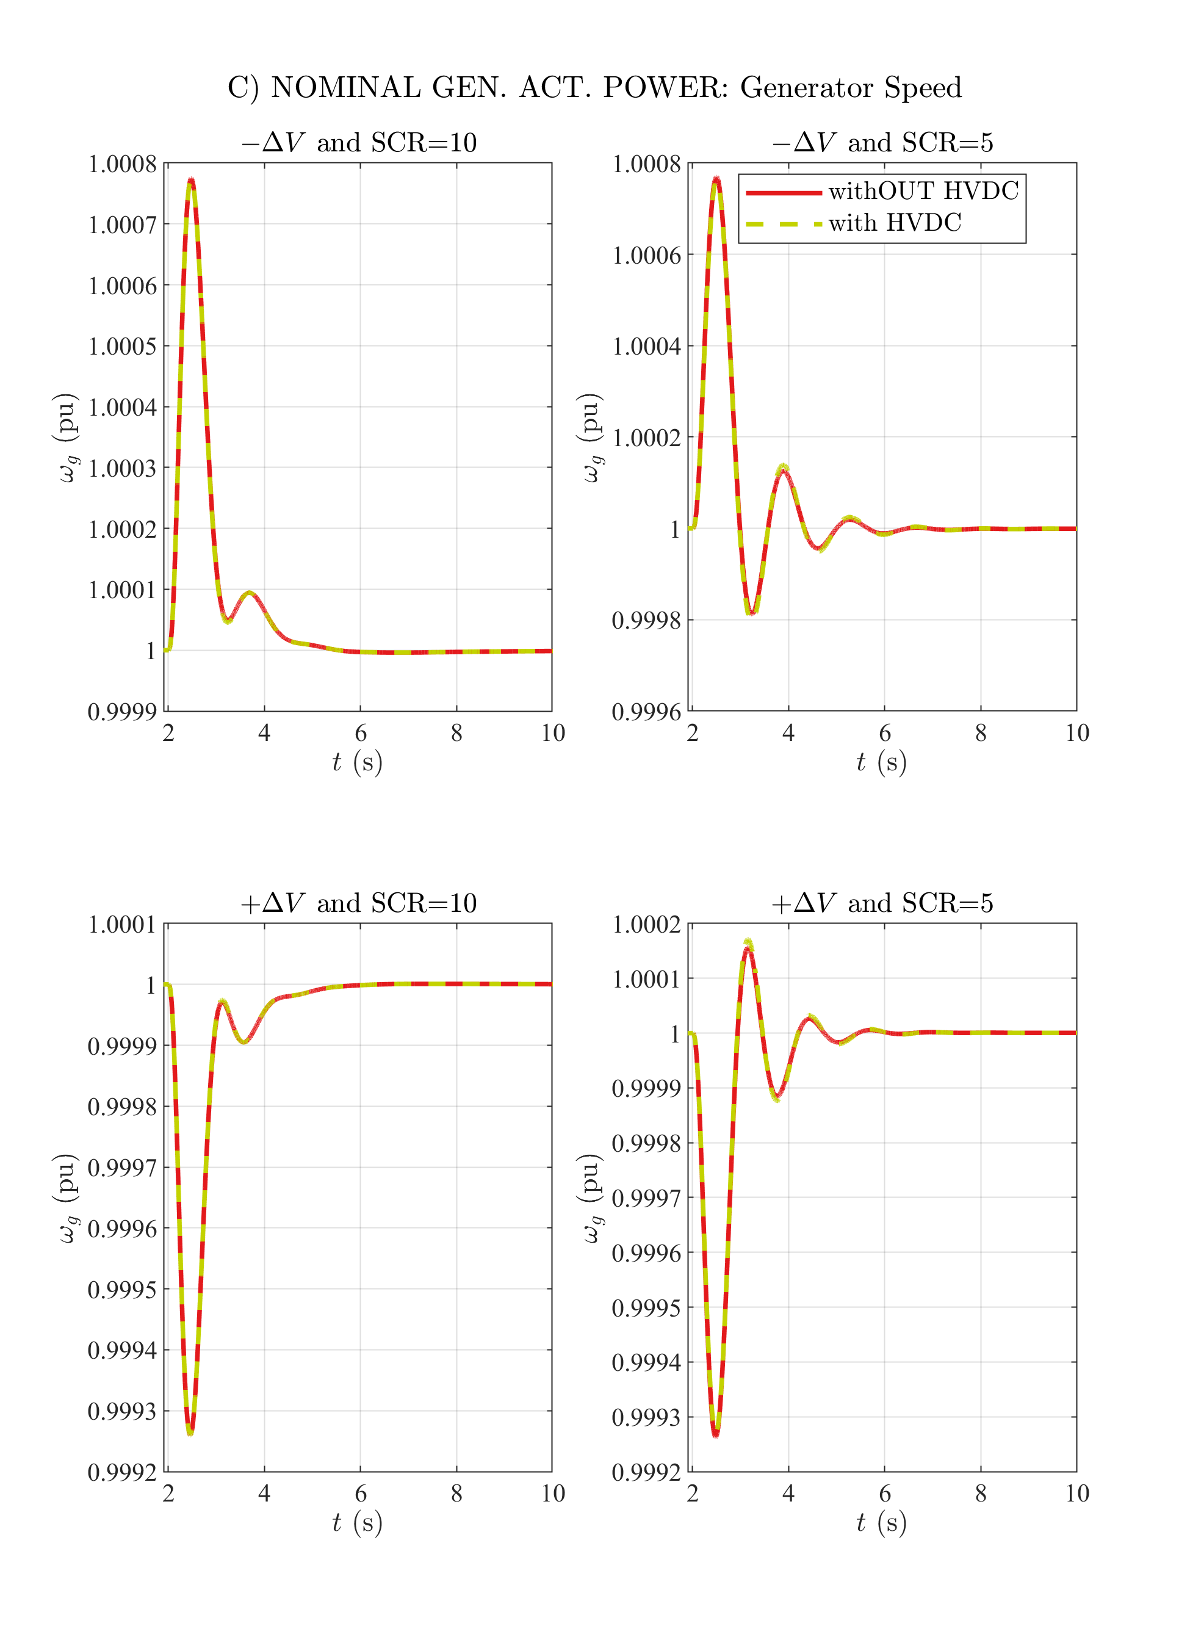

# C) NOMINAL GEN. ACT. POWER: Gen. Frequency Deviation

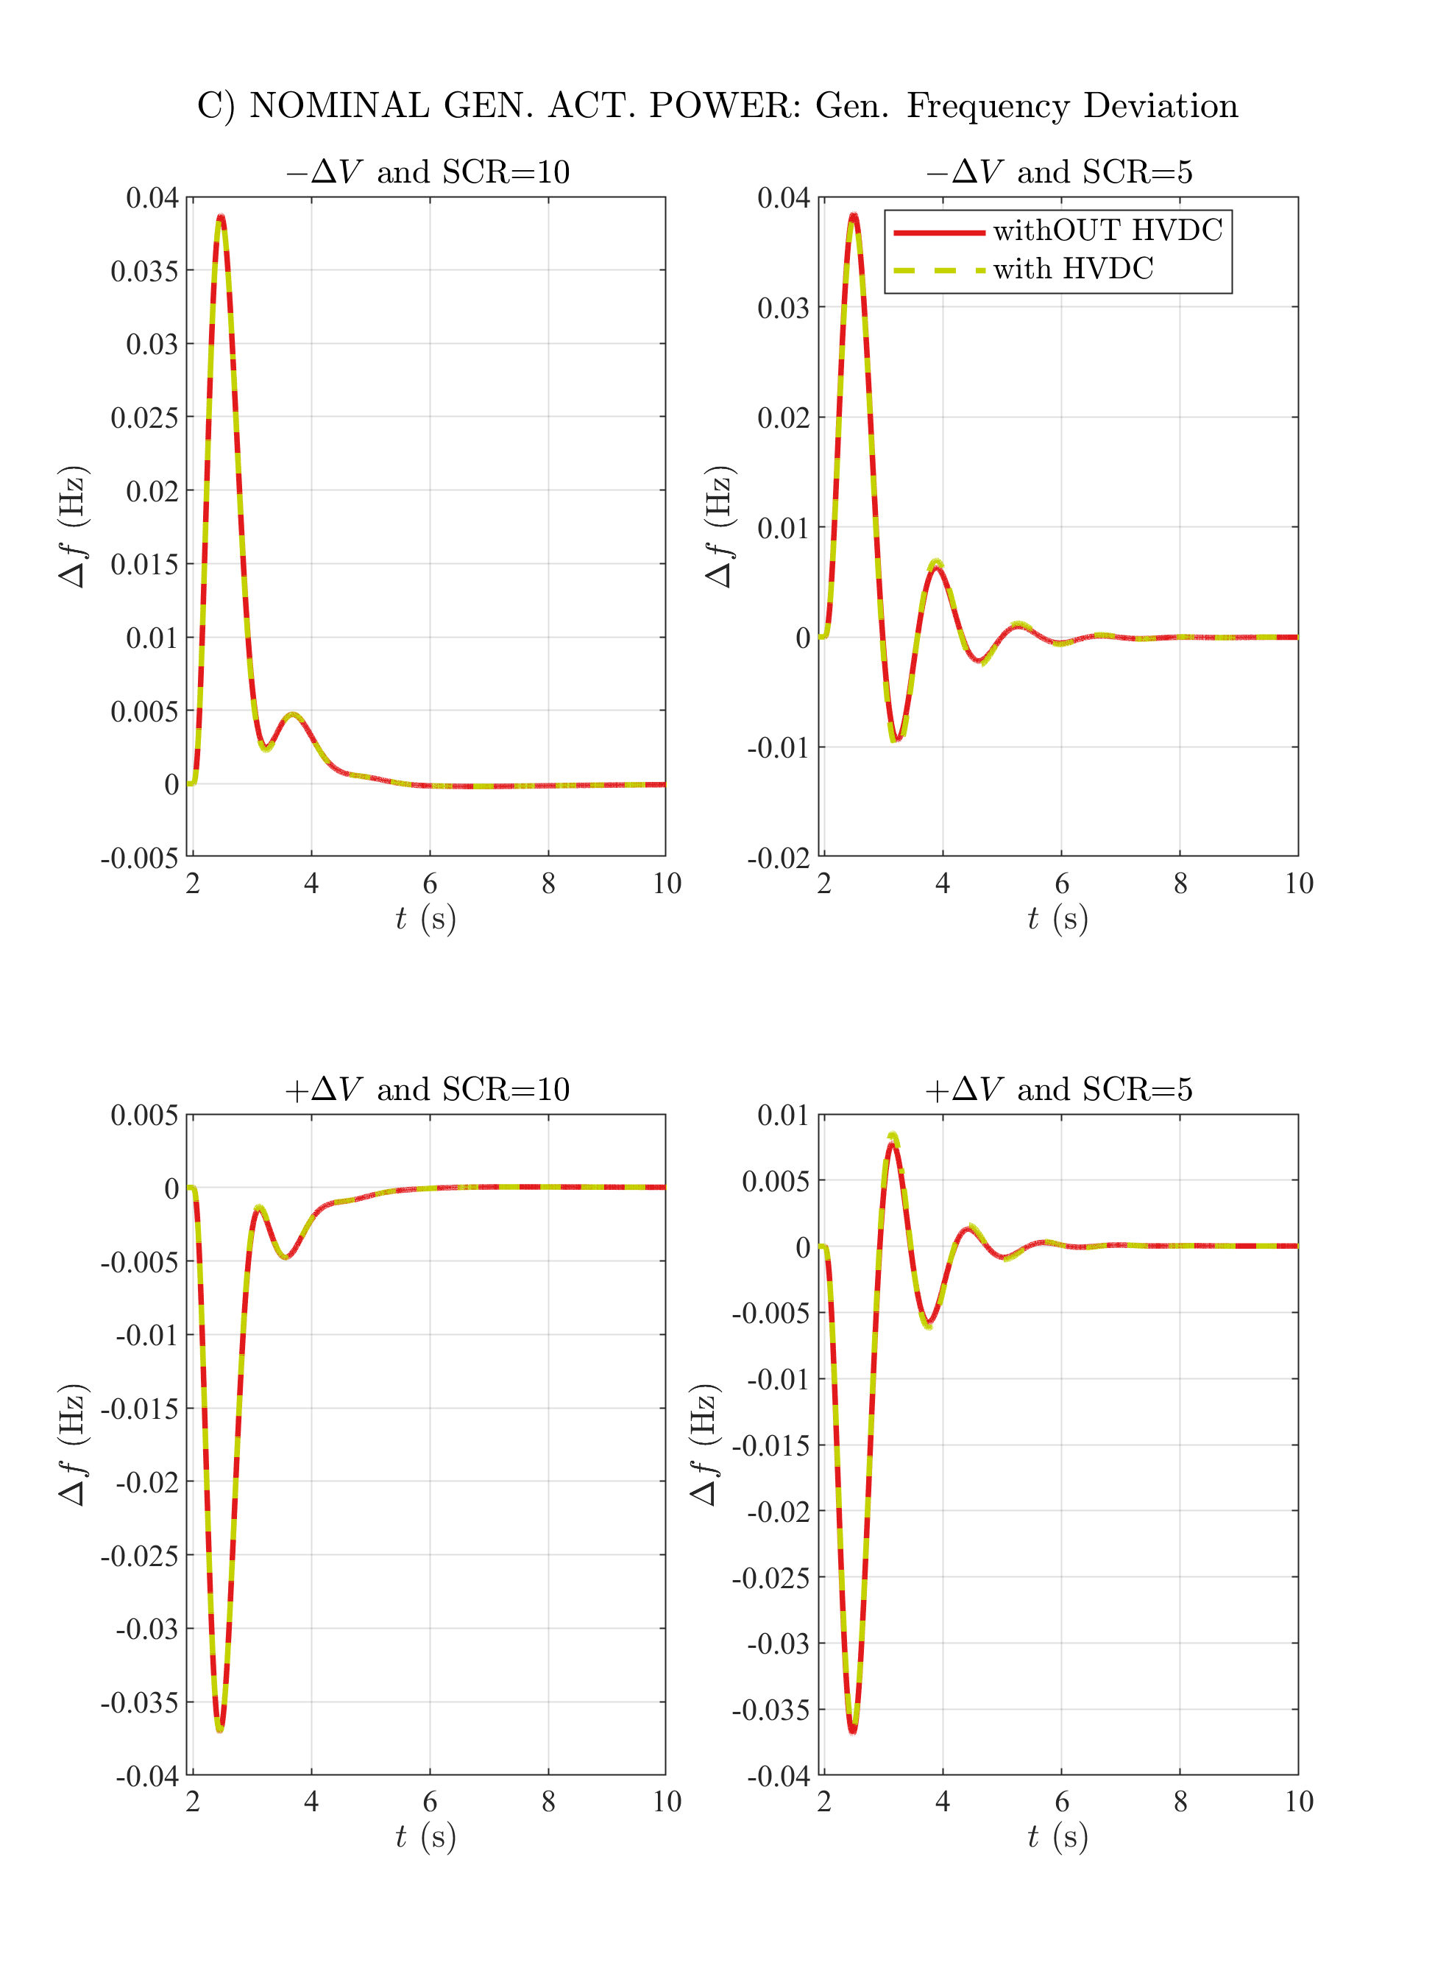

# C) NOMINAL GEN. ACT. POWER: Ext. Rotor Angle

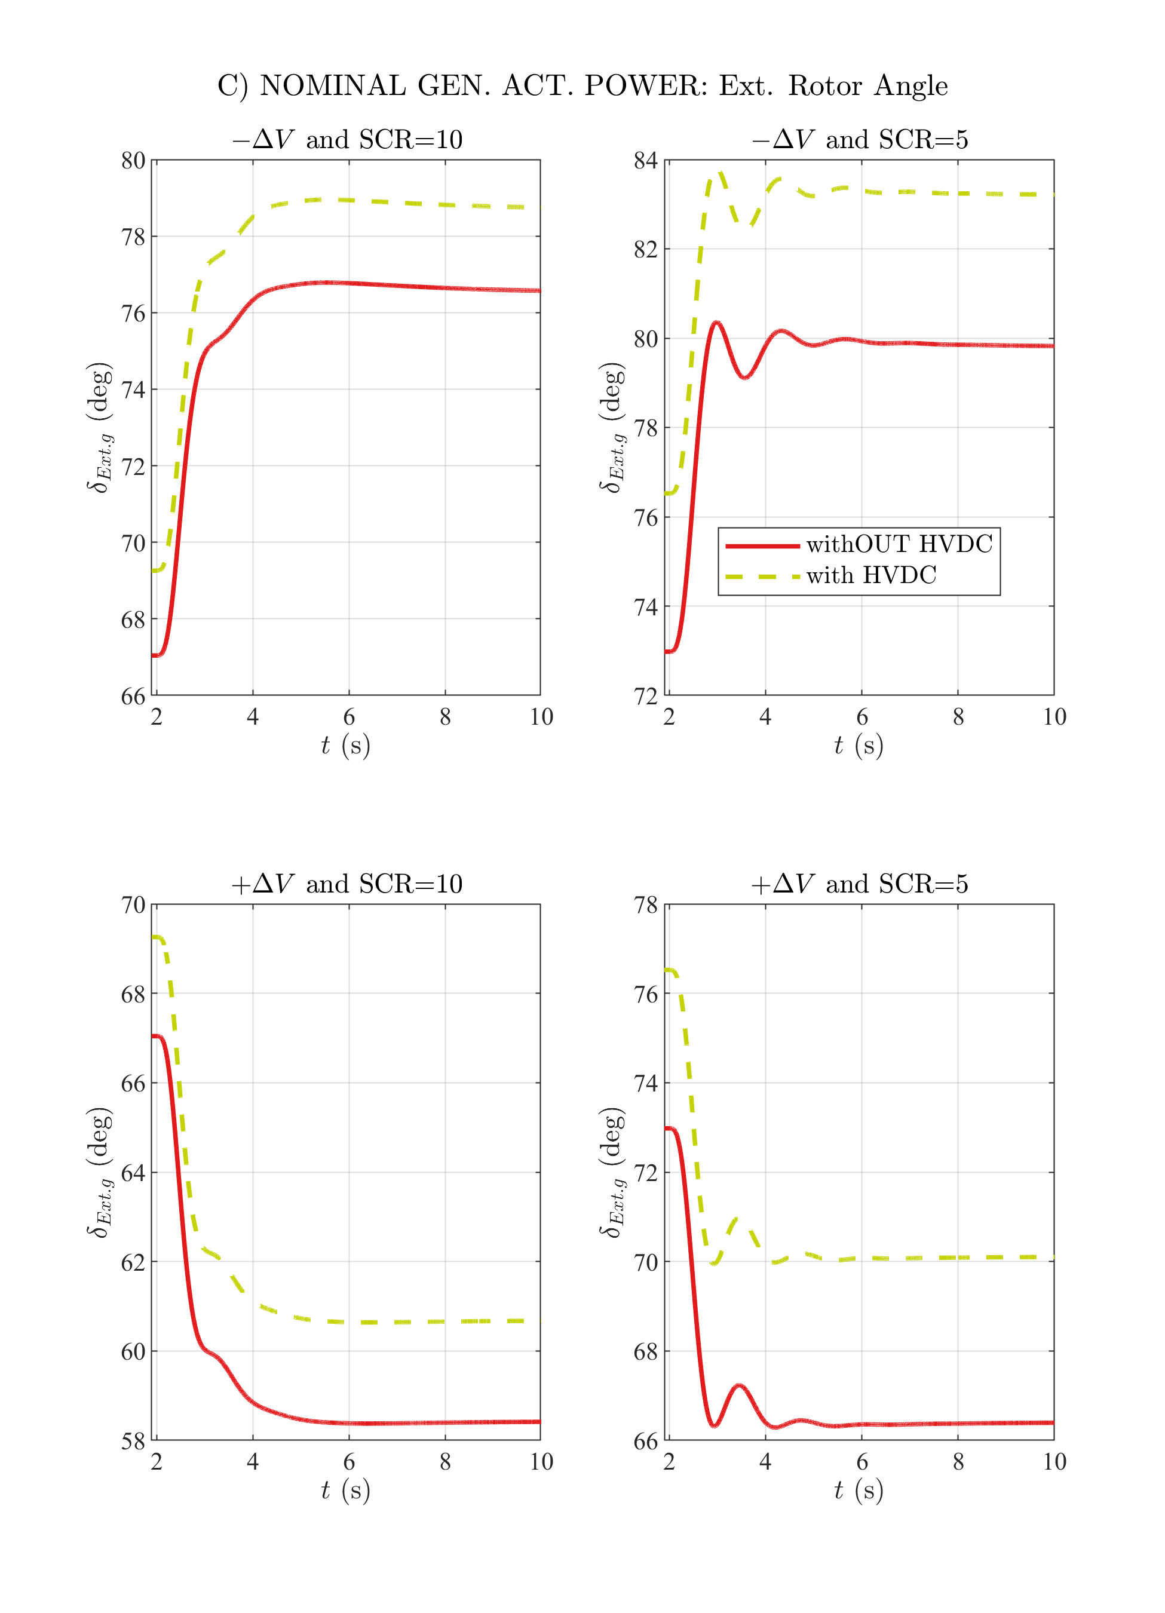

# C) NOMINAL GEN. ACT. POWER: Int. Rotor Angle

